The 2020 assessment of the snow crab (*Chionoecetes opilio*) stock  
in the southern Gulf of St. Lawrence (Areas 12, 19, 12E and 12F)

M. Hébert, T. Surette, J.-F. Landry and M. Moriyasu

Science Branch, Gulf Region  
Fisheries and Oceans Canada  
P. O. Box 5030  
Moncton, NB  
E1C 9B6

Foreword

This series documents the scientific basis for the evaluation of aquatic resources and ecosystems in Canada. As such, it addresses the issues of the day in the time frames required and the documents it contains are not intended as definitive statements on the subjects addressed but rather as progress reports on ongoing investigations.

Research documents are produced in the official language in which they are provided to the Secretariat.

Published by:

Fisheries and Oceans Canada   
Canadian Science Advisory Secretariat   
200 Kent Street  
Ottawa ON K1A 0E6

<http://www.dfo-mpo.gc.ca/csas-sccs/>   
[csas-sccs@dfo-mpo.gc.ca](mailto:csas-sccs@dfo-mpo.gc.ca)



© Her Majesty the Queen in Right of Canada, 2021  
ISSN 1919-5044

**Correct citation for this publication:**

Hébert, M., Surette T., Wade, E., Landry J.-F., and Moriyasu, M. 2021. The 2020 assessment of the snow crab (*Chionoecetes opilio*) stock in the southern Gulf of St. Lawrence (Areas 12, 19, 12E and 12F). DFO Can. Sci. Advis. Sec. Res. Doc. 2021/0XX. v + 52 p.

***Aussi disponible en français :***

*Hébert, M., Surette T., Wade, E., Landry J.-F., et Moriyasu, M. 2021. Évaluation du stock de crabe des neiges (Chionoecetes opilio) dans le sud du golfe du Saint-Laurent (zones 12, 19, 12E et 12F) en 2020. Secr. can. de consult. sci. du MPO. Doc. de rech. 2021/0XX. v + 54 p.*

TABLE OF CONTENTS

Abstract iiv

Résumé v

1.0. INTRODUCTION 1

2.0. SYNOPSIS OF SNOW CRAB BIOLOGY 1

3.0. METHODS 2

3.1. TRAWL SURVEY SAMPLING FOR BIOMASS ESTIMATION 2

3.1.1. Trawl survey in 2020 3

3.1.2. Biological sampling 4

3.1.3. Estimation of snow crab abundance 4

3.2. ESTIMATION OF THE ANNUAL TOTAL MORTALITY AND EXPLOITATION RATES 5

3.3. Risk analysis and catch options 6

4.0. RESULTS AND DISCUSSION 7

4.1. FISHERY PERFORMANCE…………………….....……………………………………………7

4.1.1. Area 12……………………………..…………………………………………………...………7

4.1.2. Area 19…………………………………………………………………………………………..7

4.1.3. Area 12E…………………………………………………………………...……………………7

4.1.4. Area 12F…………………………………………………………………………………………7

4.2. ESTIMATES OF BIOMASS AND EXPLOITATION IN 2020 7

4.2.1. Southern Gulf 7

4.2.1.1. Characteristics of trawling during the 2020 trawl survey 7

4.2.1.2. Variogram 8

4.2.1.3. Biomass estimates 8

4.2.2. Estimation of the portion of total biomass in each management fishing zone and buffer zone 9

4.2.2.1. Area 12 9

4.2.2.2. Area 19 9

4.2.2.3. Areas 12E and 12F 9

4.2.2.4. Buffer zones and unassigned zone 9

4.2.3. Exploitation rate 10

4.2.4. Total annual mortality and difference in commercial-sized adult males….. 10

4.2.5. Reproductive potential 10

5.0. RISK ANALYSIS OF CATCH OPTIONS AND PROGNOSIS 10

5.1. RISK ANALYSIS OF CATCH OPTIONS FOR 2020 10

5.2. PROGNOSIS 11

6.0. UNCERTAINTIES 11

6.1. CHANGE IN THE SURVEY PROTOCOL AND VARIABILITY IN THE COMPOSITION OF COMMERCIAL BIOMASS 11

6.2. GROWTH 15

6.3. ENVIRONMENTAL CONSIDERATIONS 16

7.0. ACKNOWLEDGMENTS 15

8.0. REFERENCES CITED 17

TABLES 1

FIGURES 10

## Abstract

The 2020 assessment of the southern Gulf of St. Lawrence (sGSL) snow crab, *Chionoecetes opilio*, stock (Areas 12, 19, 12E and 12F) is presented. Snow crab in the sGSL is considered as a single stock unit for assessment purposes. The 2020 assessment was conducted as per the recommendations of the Snow Crab Assessment Methods Framework Science Review held in November 2011. The catchability for commercial-sized adult male snow crab in the snow crab bottom trawl survey is assumed to be constant over the time series and equal to one. Biases in the indices of abundance, resulting from directional changes in catchabilities over time could arise from a number of factors in the snow crab trawl survey. Landings in the sGSL in 2020 were of 28,045 t. The catch per unit of effort (CPUE) decreased in all zones during the 2020 fishery. The overall exploitation rate of the 2020 fishery in the sGSL was 35.5%. The 2020 post-fishery survey biomass of commercial-sized adult male crabs was estimated at 77,748 t, which is similar to the 2019 estimate (79,066 t). The available biomass for the 2021 fishery, derived from the 2020 survey, is within the healthy zone of the Precautionary Approach (PA) Framework. The residual biomass from the 2020 survey was estimated at 19,107 t, a decrease of 5.8% compared to the 2019 survey estimate (20,291 t). Seventy-five percent (75%) of the 2020 survey biomass, available for the 2021 fishery, is composed of new recruitment (58,438 t). The recruitment to the commercial biomass from the 2020 survey is similar to 2019 (58,995 t). Based on the agreed harvest decision rule, the point estimate of the biomass in the 2020 survey of 77,748 t corresponds to an exploitation rate of 40.4% and a total allowable catch of 31,410 t for the 2021 fishery. At this harvest level, there is zero chance of residual biomass post-fishery in 2021 being in the critical zone. The biomass of commercial-sized adult males is considered to be at a high level and in the healthy zone of the PA. There is a broad distribution of snow crab in the sGSL and continued positive signs of sustained recruitment and high female abundances.

## Résumé

L’évaluation du stock de crabe des neiges, *Chionoecetes opilio*, du sud du golfe du Saint-Laurent (sgSL) de 2020 est présentée (zones 12, 19 12E et 12F). Le crabe des neiges dans le sgSL est considéré comme une seule unité de stock aux fins d’évaluation. L’évaluation de 2020 a été effectuée selon les recommandations suite à l’examen cadre des méthodes d'évaluation du stock de crabe des neiges dans le sgSL tenu en novembre 2011. Les débarquements dans le sgSL en 2020 ont atteint 28 045 t. Les captures par unité d’effort (CPUE) ont diminué dans toutes les zones lors de la pêche de 2020. Le taux d’exploitation pour la pêche de 2020 dans le sgSL était de 35,5%. Selon le relevé effectué après la pêche de 2020, la biomasse de crabes adultes de taille commerciale a été estimée à 77 748 t ce qui est similaire à celle de 2019 (79 066 t). Le niveau de la biomasse pour la pêche de 2021, provenant du relevé de 2020, se situe dans la zone saine du cadre de l’approche de précaution (AP). La biomasse résiduelle à partir du relevé de 2020 a été estimée à 19 107 t, une diminution de 5,8% par rapport au relevé de 2019 (20 291 t). Soixante-quinze pourcent (75%) de la biomasse du relevé de 2020 exploitable pour la pêche de 2021 est composée de nouvelles recrues (58 438 t). Le recrutement à la biomasse commerciale estimé à partir du relevé de 2020 est similaire à celui de 2019 (58 995 t). Compte tenu de la règle de décision convenue qui a été évaluée comme conforme à l’AP, l’estimation ponctuelle de la biomasse du relevé de 2020 de 77 748 t correspond à un taux d’exploitation de 40,4 % et à un total autorisé des captures de 31 410 t pour la pêche de 2021. À ce niveau d’exploitation, il n’y aurait aucune chance que la biomasse résiduelle, après la pêche de 2021, se retrouve dans la zone critique. La biomasse des mâles adultes de taille commerciale est considérée être à un niveau élevé et dans la zone saine de l’AP. Il y a une vaste distribution de crabe des neiges dans le sgSL et des signes positifs continuels de recrutement soutenu et d’abondances élevées de femelles.

## 1.0. INTRODUCTION

Snow crab, *Chionoecetes opilio*, has been commercially exploited in the southern Gulf of St. Lawrence (sGSL) since the mid-1960s. Until 1994, the snow crab fishery in Area 12 (Fig. 1) was exploited by 130 mid-shore crab harvesters from New Brunswick, Québec and Nova Scotia. In 1997, the Prince Edward Island (PEI) coastal fishery (formerly called Areas 25/26) was integrated into Area 12. In 2003, a portion of the coastal fishery off Cape Breton (formerly called Area 18) was also integrated into Area 12, and a northern part of Area 18 was set as a buffer zone (non-snow crab fishing zone, label C in Fig. 1). For the purpose of this assessment, Area 12 refers to the new management unit (Fig. 1). In 1978, Area 19 (Fig. 1) was established for the exclusive use of Cape Breton inshore crab harvesters with vessels less than 13.7 m (45 ft) in length. Areas 12E and 12F were introduced in 1995 as exploratory fishery areas. A two nautical mile buffer zone was created between Area 12F and the adjacent Area 19 in 1996 (label B in Fig. 1). In 2002, the status of Areas 12E and 12F was changed from exploratory to commercial.

Currently, there are four individually managed fishing areas (Areas 12, 19, 12E and 12F) (Fig. 1), with Area 12 being the largest in area, number of participants, and landings. There is no biological basis for the delimitations of snow crab management areas in the sGSL (Chiasson and Hébert 1990; Hébert et al. 2008; DFO 2009). Crabs in the above four management areas are considered part of a single biological population and the sGSL is considered as a single unit for assessment purposes (Hébert et al. 2008).

Management of the snow crab fisheryis based on quotas (by management area and distributed among license holders) and effort controls (number of licenses, trap allocations, trap dimensions, and seasons).In Areas 12, 12E and 12F, the fishing season generally starts as soon as the sGSL is clear of ice in late April to early May and lasts either until the closure of the fishing season in mid-July or when the quota is caught. In Area 19, the fishing season starts in July and ends in mid-September or when the quota is caught. The landing of females is prohibited and only hard-shelled males ≥ 95 mm carapace width (CW) are commercially exploited. Different limits on the number of traps apply to each license depending on the harvesters group and fishing area.

New management measures were introduced in 1990 following the premature closure of the Area 12 fishery in 1989 due to a rapid decline in catch rates and high incidence of soft-shelled crabs in catches. One of the measures was to set the total allowable catch (TAC) or quota as some proportion of the biomass of adult male crab ≥ 95 mm CW, as estimated from a trawl survey. Another management strategy was to close portions of the fishery based on the percentage of soft- or white crabs to maximize yield and reproductive potential by limiting the capture of soft-shelled males.

This assessment follows recommendations from the Framework Science Peer Review of stock assessment methods for the sGSL snow crab stock held on November 21-25, 2011 (DFO 2012a).

The present report presents a brief summary of the 2020 snow crab fishery, the stock status assessment, and commercial biomass estimates for the 2021 sGSL snow crab fishery. Biomass estimates and population characteristics by life stage are derived from a trawl survey conducted after the fishery covering the sGSL snow crab habitat. A risk analysis of catch options for the 2021 fishery relative to the commercial biomass and removal reference points is also presented.

## 2.0. SYNOPSIS OF SNOW CRAB BIOLOGY

In the sGSL, molting of snow crab occurs from December to April, prior to the fishery (Watson 1972; Conan et al. 1988; Sainte-Marie et al. 1995; Benhalima et al. 1998; Hébert et al. 2002). Crab normally molt annually until they reach the adult phase via a final or “terminal” molt (Conan and Comeau 1986). Males reach adulthood at sizes ranging from 40 to 150 mm CW and females at 30 to 95 mm CW (Conan and Comeau 1986). Estimates of longevity of adult males are (after reaching the terminal molt) between 5 (Sainte-Marie et al. 1995) and 8 years (Fonseca et al. 2008).

In contrast to immature females, pubescent (adolescent) females have a wider abdomen and fully developed orange gonads in the fall. These females then undergo a terminal molt between December and April and become nulliparous females having a fully enlarged abdomen and ripe ovaries. Generally, they mate immediately after molting, while their carapace is still soft, and then extrude fertilized eggs for the first time, becoming primiparous females (Watson 1969; Moriyasu and Conan 1988). Multiparous refers to females which are repeat spawners (second brood or more). Their mating season occurs from late-May to early-June, after their eggs have hatched (Conan and Comeau 1986; Moriyasu and Conan 1988; Sainte-Marie and Hazel 1992; Moriyasu and Comeau 1996; Sainte-Marie et al. 1999). In the sGSL, mature females normally carry their eggs under the abdomen for two years (Mallet et al. 1993; Moriyasu and Lanteigne 1998), while a negligible portion of mature females follow a one-year cycle in Baie Sainte-Marguerite (Sainte-Marie et al. 1995). However, Khun and Choi (2011) reported that over 80% of mature females were estimated to follow a one-year reproductive cycle on the Scotian Shelf.

Mature females, both primiparous and multiparous, may produce more than one viable brood from sperm stored in their spermathecae from the first mating, without any subsequent mating (Sainte-Marie and Carrière 1995). However, the probability that a single mating was sufficient to fertilize a female’s lifetime production of eggs has been shown to be low (Rondeau and Sainte-Marie 2001). Mating after egg hatching seems to be a general rule for snow crab in the sGSL (Conan et al. 1988).

After molting, crabs have a soft shell engorged with water. It takes about 8-10 months for the carapace of an adult soft-shelled male to harden (Hébert et al. 2002) and one year to attain maximal meat yield (Dufour et al. 1997). Adult soft-shelled males are not able to mate during their postmolt period, but become active in reproductive activities with nulliparous females in February of the following year and in May-June with multiparous females (Conan et al. 1988; Moriyasu et al. 1988). Adult soft-shelled males of legal size represent the annual recruitment to the fishery, as they become commercially marketable in the following fishing season (Conan and Comeau 1986; Sainte-Marie et al. 1995; Comeau et al. 1998; Hébert et al. 2002).

Following Sainte-Marie et al. (1995), we use the term “adolescent” and “adult” to refer to what was formerly called morphometrically immature and mature, respectively (Conan and Comeau 1986).

## 3.0. METHODS

Due to the Covid-19 pandemic, there were no at-sea observers deployed onboard snow crab vessels during the 2020 fishing season. Consequently, the soft-shelled and white shelled crab protocols were not applied during the 2020 fishing season. All analyses based on at-sea observer data to monitor the fishery performance such as the catch composition, the percentage of-soft-shelled or white crabs, the CPUE and the mean size of commercial-sized adult males could not performed for the 2020 fishing season.

**3.1. LOGBOOKS AND LANDING MONITORING**

Raw data on catches and fishing effort were obtained from mandatory logbooks and the quota monitoring report, which is based on dockside monitoring of landings. The data were compiled by the Statistics Divisions of the Quebec and Gulf Regions of The Department of Fisheries and Oceans (DFO), and verified by Science Gulf Region. Information on revised quotas, allocation shares, maximum trap allocations, and opening dates for the fishery per area were obtained from DFO Fishery and Aquaculture Management sector.

The geographic distribution of fishing effort is presented as the total number of trap hauls within each 10 by 10 minutes latitude-longitude grid. Fishing positions were obtained from logbooks.

The mean catch-per-unit-of-effort (CPUE) in kilograms per trap haul (kg/th) of the fleet in year (i) was calculated as the ratio of total catches (yi) and the corresponding number of trap hauls (thi) as reported in the logbooks: CPUEi = yi / thi. As not all trap hauls were reported in the logbooks, the total trap hauls had to be estimated. Thus the total effort in the fishery (total number of trap hauls, TH) was estimated from the total landings from the quota monitoring report (Yi) divided by the unadjusted mean CPUE: THi = Yi / CPUEi. Trap immersion times were taken from the logbooks.

## 3.2. TRAWL SURVEY SAMPLING FOR BIOMASS ESTIMATION

There have been progressive changes in the sampling design and protocols of the sGSL trawl survey since its inception in 1988. Originally, the survey area was sub-divided using a lattice of 10 by 10 minute latitude-longitude grids. One or two sampling locations were then randomly selected and used as fixed stations in subsequent survey years. The sampling design from 2006 to 2011 was modified in accordance with recommendations from the 2005 Assessment Framework Workshop on the sGSL snow crab (DFO 2006; Moriyasu et al. 2008).

In 2012, the sampling design was again modified following recommendations from the 2011 Snow Crab Assessment Methods Framework Science Review (DFO 2012a). The boundaries of the survey area were extended to the 20 and 200 fathom isobaths, encompassing the vast majority of favorable snow crab habitat (i.e. bottom temperatures less than 5°C) and thus the sGSL biological unit. To further improve spatial homogeneity, grids were set to be square rather than rectangular with dimensions defined as a function of the number of total samples, so that each grid included only a single sampling station (DFO 2012a). This protocol resulted in an entirely new set of sampling stations. The revised survey sampling design in 2012 is presented in Wade et al. (2014). For 2013, the number of stations increased from 325 to 355 following recommendations from the snow crab advisory committee to increase the precision of the biomass estimates in smaller fishing zones. The survey area was partitioned into square grids of 12.7 km x 12.7 km and a new set of sampling stations was generated.

Since 2014, the number of target sampling stations has remained at 355 and the successfully sampled stations from the previous year survey were used as fixed stations. A new set of sampling stations was generated randomly when sampling stations were abandoned or if the sampling stations were outside of their assigned square grids.

## 3.1.2. Trawl survey in 2020

In 2020, the number of target sampling stations remained at 355. The 350 successful sampling stations from the 2019 trawl survey were used as fixed stations in 2020 and a new set of five sampling stations (the three sampling stations that were abandoned and two sampling stations that were conducted outside their assigned square grid areas in 2019) was generated randomly (Fig. 2).

The trawl survey was conducted between July 13 and September 10 and covered Areas 12, 19, 12E and 12F (Fig. 2). A new vessel, the Avalon Voyager II, a 65 foot stern-trawling (850 HP) fiberglass boat, was used to conduct the trawl survey since 2019. A total of 353 stations were successfully trawled in 2020; two sampling squares had to be abandoned due to failures to successfully trawl the area. For a description of the trawl used, see Moriyasu et al. 2008.

All stations were trawled during the interval between morning and evening civil twilight hours. A predetermined amount of warp was let out (three times the distance of the depth) before the winch drums were locked. The start time of a standard tow was based on the information reported by the eSonar depth and height sensors, later revised using data from StarOddi temperature-depth and tilt probes attached to the trawl. The target duration of each tow was five minutes at a target speed of two knots. The horizontal opening of the trawl was recorded every four seconds with the eSonar distance sensors. The swept distance of the trawl was estimated from the position (latitude/longitude) measured every second with a Differential Global Positioning System. The swept area for each tow was calculated by multiplying the swept distance and the horizontal opening of the trawl over the duration of the tow.

Adjustments to the trawling operations and protocol were made in 2020 to address issues raised during last year’s assessment, mostly the extended duration of the passive trawling phase (Hebert et al. 2021). In order to limit the length of that phase, the speed of the winches was set at 1.25 m/s, similar to the winch speed on the Jean-Mathieu, the vessel used from 2013 to 2018, by adjusting the revolutions per minute (RPM) of the hydraulic system at 1,500 RPM. In addition, the speed of the vessel was reduced at its slowest after the 5 minutes tow to minimize any movement forward of the trawl before it was hauled back.

Tows were rejected if the net was damaged, the eSonar system generated no usable data to determine the beginning of the tow, or the duration of the tow was less than five minutes. A replacement tow was conducted near the original start point or at the alternate sampling stations within the assigned grid (Fig. 2).

If the tow satisfied trawl survey protocols but the data signal quality from the eSonar sensors was deemed to be inadequate to calculate the swept area, the swept area of the tow was set to the average of the values of the 10 nearest stations.

**3.2.1.1.High catches in 2019 and 2020 (TOBIE)**

Snow crab catches in the 2019 and 2020 survey seemed to be unexpectedly high compared to past surveys. These increases were observed throughout the sGSL. To investigate these record high catches, we checked for possible differences in vessel or trawl behavior between the 2017, 2018, 2019 and 2020 surveys.

In particular, we verified whether there was any evidence of the trawl being dragged after the nominal 5-minute trawling period. Currently, the swept area is calculated from when the winches are locked and the trawl touches the bottom until the stop signal is given at the 5 minute mark, whereupon the vessel slows and the trawl winches are activated. To clarify this discussion, we divide the period where the trawl lies on the sea bottom into an active trawling phase and a passive trawling phase (Fig. 3).

* Active phase: After reaching the predetermined target amount of warp, the winches are locked and the vessel slows to the target trawling speed of two knots. When the trawl reaches the bottom, as determined from the e-Sonar® depth, height and distance sensors attached to the trawl, the active trawling phase begins with a duration of five minutes (300 seconds), where upon a stop signal is given by the chief scientist.
* Passive trawling phase: After the stop signal, the winches are unlocked and start to reel in the trawl. During this phase, the vessel slows and the trawl remains on the bottom and continues to be dragged by the forward movement of the vessel as well as the action of the winches. This phase ends when the trawl lifts off the bottom, as determined by the tilt Star-Oddi© sensor attached to the footrope of the trawl.

## 3.2.2. Biological sampling

The trawl catches were sorted on the vessel deck. Snow crabs were put aside for detailed sampling. All other organisms were sorted by species or species group and counted. Since 2010, individual length measurements for all fish species were made at 100 randomly selected stations. Fish length sampling was based on random sub-samples of up to 100 individuals of each fish species in a selected tow. Starting in 2013, all species or species groups were weighed.

The following information was recorded for all snow crabs: carapace width (CW), chela height (CH) for males only to the nearest 0.1 mm and carapace condition (Hébert et al. 1997). For females, the color (orange, dark orange, brown or black) and quantity (in percentages) of external eggs on ovigerous females, as well as the color (white, beige or orange) of the gonads of immature females were also noted.

The size frequency distributions for the population were derived from the samples weighted by the swept area (km²) of each corresponding tow.

## 3.2.3. Estimation of snow crab abundance

The assessment follows the recommendations from the November 2011 Framework Science Peer Review of stock assessment methods for the sGSL snow crab stock (DFO 2012a).

The survey area polygon has a total area of 57,842.8 km2 (Fig. 4) and the four corresponding management areas have areas of 48,074 km2 for Area 12, 3,813 km2 for Area 19, 2,436.9 km2 for Area 12E and 2,426.8 km2 for Area 12F (Fig. 4). An additional unassigned zone A (above Areas 12E and 12F, Fig. 4) is included in the expanded polygon and located where no fishing activities were observed. This zone has an area of 667.9 km2, while the buffer zones B and C (Fig. 4) cover an area of 134.2 and 289.5 km2, respectively.

The sGSL biomass estimates includes the unassigned zone A and the buffer zones B and C (no fishing zones) (Fig. 4). Commercial biomass estimates in each management zone 12, 19, 12E and 12F were calculated excluding the buffer zones.

Commercial biomass estimates were also calculated for each of the buffer zones (B and C) and for the unassigned zone (A).

The current model, kriging with external drift (KED) using depth as a secondary variable, used for the snow crab assessment is considered suitable for biomass estimates (DFO 2012a).

A three-year average for the global variogram was calculated as this has been considered a more stable method for modeling the autocorrelation between the samples (Wade et al. 2014).

The 1997 to 2020 time series of estimated biomasses for the sGSL, using the expanded polygon of 57,842.8 km2, was considered as a standardized time series for the purpose of stock assessment, development of reference points and provision of catch advice.

Kriging analyses were performed using the language programming version R 3.4 for the 2020 stock assessment.

Biomass was estimated using KED on commercial-sized adult catch weights (Wade et al. 2014), with the weight estimated using the size-weight relationship:

W = (2.665 x 10-4) CW 3.098

where W is the weight in grams and CW is the carapace width in mm (Hébert et al. 1992).

Total biomasses were estimated for the following categories of male crab:

* commercial-sized adult male ≥ 95 mm CW all carapace conditions,
* commercial-sized adult male crab ≥ 95 mm CW with carapace conditions 1 and 2 at the time of the survey, which represents the annual recruitment to the fishery (called R-1), and
* adult male crab ≥ 95 mm CW with carapace conditions 3, 4 and 5 (hard-shelled) at the time of the survey, which represent the residual or remaining biomass post- fishery.

The abundance indices of prerecruits at the time of the survey (R-4, R-3 and R-2) were used to forecast the recruitment to the fishery over the next four years. Stages R-4, R-3 and R-2 represent adolescent males with a CW range of 56-68 mm, 69-83 mm and larger than 83 mm, respectively, and they are expected to recruit (CW ≥ 95 mm) to the fishery in four, three and two years, respectively. The size increments from molting of pre-recruits R-4, R-3 and R-2 were set using a growth model for adolescent male snow crab (Hébert et al. 2002). The abundance of adolescent males of instar VIII, defined as those with a CW between 34 and 44 mm, was also estimated as an index of longer term recruitment. It takes at least six years for an adolescent male of instar VIII to reach the commercial size of 95 mm CW. In addition, the abundance indices of pubescent, primiparous and multiparous females were estimated.

## 3.3. ESTIMATION OF THE ANNUAL TOTAL MORTALITY AND EXPLOITATION RATES

Total annual mortality of commercial-sized adult males, expressed as a proportion, is estimated as:

*Nt3,4,5 / Nt-1*

Where *Nt345* is the biomass of commercial-sized adult males with carapace conditions 3, 4 and 5 after the fishery in year *t* (the residual biomass) and *N(t-1)* is the abundance of commercial-sized males with carapace conditions 1 to 5 after the fishery in year *t-1* (the commercial biomass in the previous year).

The exploitation rates *(ER)* was calculated as the ratio of the catch *(t)* in the fishery of year *t* (*Ct3,4,5*) and the commercial biomass (*Bt-1*) from the previous year.

*ER = Ct3,4,5 / Bt-1*

This exploitation rate does not take into account the natural mortality before and during the fishery.

## 3.4. Risk analysis and catch options

The Bayesian model described by Surette and Wade (2006) and Wade et al. (2014) was used to forecast the biomass of recruitment to the fishery (R-1) based on survey abundances of pre-recruits R-4, R-3 and R-2 from the sGSL, to project four, three and two year(s) into the future, respectively. The model incorporated uncertainties associated with observation errors.

## 4.0. RESULTS

**4.1. FISHERY PERFORMANCE**

Since 1969, snow crab landings in the sGSL have shown four periods of high landings (exceeding 20,000 t): 1981-1986, 1994-1995, 2002-2009 and more recently from 2012 to 2020 (Fig. 5). The landings in the sGSL were 28,045 t in 2020 (revised quota of 31,152 t) while they were 31,707 t in 2019 (revised quota of 32,215 t) (Table 1; Fig. 5). For reasons of interannual quota adjustments, reconciliations, and re-distribution of the scientific quota among areas, the revised quota does not necessarily correspond to the TAC in the notice to harvesters. In the notice of harvesters, the allowable quota for the sGSL was 31,341 t in 2020.

**4.1.1. Area 12**

The 2020 fishing season in Area 12 opened on April 24 and the last landings were recorded on July 1 with reported landings of 24,525 t from revised quota of 27,435 t, which represents 89.4% of the quota. The allowable quota from the notice to harvesters was 27,204 t. Harvesters participating in the fishery were from New-Brunswick, Quebec, Nova Scotia and Prince Edward Island. The number of participating boats was 309 in 2020 while it was 321 in 2019.

Main fishing grounds are shown in Figure 1. The estimated fishing effort in Area 12 has varied from 243,339 to 544,454 trap hauls (th) between 1987 and 2009, but decreased considerably to 161,148 th in 2010, the lowest value of the time series since 1987 (Table 1). The fishing effort increased since then to 339,912 th in 2015 but decreased to 304,624 th in 2016 (Table 1). In 2017, the fishing effort increased to 553,125 th, the highest since 1987 (Table 1). In 2020, the fishing effort was 556,125 th, an increase from 2019 (496,468 th) (Table 1). During the 2020 fishing season, fishing effort in Area 12 was concentrated mostly in Chaleur Bay, the Shediac valley, the Bradelle Bank, the Magdalen Channel and the Cape Breton Corridor (Fig. 6) where the majority of landings were taken (Fig. 7).

The mean CPUE (called CPUE hereafter) estimated from logbooks in Area 12 was 44.1 kg/th in 2020, a decrease compared to 2019 at 55.5 kg/th (Table 1). High CPUEs were observed in Bradelle bank, Orphan bank, the northern and central parts of the Magdalen Channel and in the Cape Breton Corridor (Fig. 8).

The mean trap immersion times are summarized in Table 2a. Since 1997, the mean trap immersion time in Area 12 has varied from 55 hours (2003) to 88 hours (2017). The mean trap immersion time in 2020 was 75 hours while it was 73 hours in 2019 (Table 2a).

**4.1.2. Area 19**

The 2020 fishing season in Area 19 opened on July 2 and the last landings were recorded on August 13 with reported landings of 2,284 t from a revised quota of 2,287 t. The allowable quota from the notice to harvesters was 2,255 t. The number of boats fishing in Area 19 in 2020 was 103 (all from Cape Breton) compared to 109 in 2019.

The fishing effort during 2020 in Area 19 was concentrated in the southern part of the zone where the highest landings were taken while high CPUEs were observed all over the zone (Figs. 6, 7 and 8). The fishing effort has varied from 16,733 th to 55,977 th between 1987 and 2009, but decreased considerably to 11,138 th in 2010, the lowest value of the time series (Table 1). The fishing effort increased to 25,407 th in 2014 and decreased to 11,937 th by 2016 (Table 1). In 2019, the fishing effort increased to 24,518 th but decreased to 22,458 th in 2020 (Table 1).

The mean CPUE remained high in 2020 (101.7 kg/th), a decrease compared to 2019 (112.7 kg/th (Table 1). The highest mean CPUE was observed in 2012 at 178.1 kg/th (Table 1).

Since 1997, the mean trap immersion time in Area 19 has varied from 28 hours (2004) and 38 hours (2003 and 2017) (Table 2a). In 2020, the mean trap immersion time was 33 hours, while it was 31 hours in 2019 (Table 2a).

**4.1.3. Area 12E**

In Area 12E, the 2020 fishery opened on April 24 and the last landings were recorded on June 30, with reported landings of 234 t from a revised quota of 238 t. The quota from the notice to harvesters was 239 t. Four fish harvesters were active for the 2020 fishing season.

Harvesters concentrated their fishing effort in the southeastern part of the area adjacent to Areas 12 and 12F (Fig. 6). The fishing effort decreased from 9,232 th in 2008 to 1,825 th in 2010 but increased to 5,623 th in 2012 (Table 1). The fishing effort decreased to 2,796 th by 2016 (Table 1). Since 2016, the fishing effort increased to reach 5,579 th in 2018 (Table1). In 2019, the fishing effort decreased to 3,415 th but increased to 5,098 th in 2020 (Table 1).

The Area 12E mean CPUE estimated from logbooks was 45.9 kg/th in 2019, a decrease compared to 65.7 kg/th in 2019 (Table 1).

Since 1997, the mean trap immersion time has varied between 30 hours in 1998 and 72 hours in 2009. The mean trap immersion time decreased to 54 hours in 2020 compared to 66 hours in 2019 (Table 2b).

**4.1.4. Area 12F**

In Area 12F, the 2020 fishery opened on April 24 and the last landings were recorded on July 1 with reported landings of 1,002 t from a revised quota of 1,192 t. The allowable quota from the notice to harvesters was 1,192 t. There were 15 traditional (10 were from the Magdalen Islands and 5 from Cape Breton) and 32 temporary fish harvesters in 2020.

The fishing effort was distributed all over Area 12F (Fig. 6). The fishing effort decreased from 16,890 th in 2012 to 11,086 th in 2013 but increased to 23,163 th in 2014 (Table 1). The fishing effort decreased to 8,667 th by 2016 but increased to 22,168 th in 2020 (Table 1).

The Area 12F mean CPUE estimated from logbooks decreased in 2020 (45.2 kg/th) compared to 2019 (64.5 kg/th, Table 1).

Since 1997, the mean trap immersion time has varied between 49 hours (1997) and 118 hours (2011). The mean trap immersion time in 2020 (88 hours) increased compared to 2019 (83 hours, Table 2b).

## 4.2. ESTIMATES OF BIOMASS AND EXPLOITATION IN 2020

## 4.2.1. Southern Gulf

## 4.2.1.1. trawling characteristics during the 2020 survey (TOBIE)

There were some differences between the Avalon Voyager II compared to the former vessel, the ‘’Jean-Mathieu’’. First, the winches aboard the Avalon Voyager II’ were limited to two speed settings, a higher and lower speed settings. The higher speed setting at high revolutions per minutes (RPM) used during the first survey trip in the 2019 trawl survey resulted in gear entanglements.

In 2019 and 2020, the median duration of the passive phase were 89 seconds and 88 seconds on the “Avalon Voyager II’’, almost twice that of the “Jean-Mathieu’’ in 2017 (50.5 seconds) and 2018 (43 seconds) (Table 3).

The calculated winch speeds were comparable during the 2017 and 2018 with median values of 1.26 meters per second, whereas the 2019 median dropped to 0.90 meters per second (Table 3).

**Figure 9. Explain TOBIE ☺**

Slower winch speeds in 2019 led to increases in the length of time the trawl spends on the bottom during the passive trawling phase. The increased distance travelled by the trawl is due to two main factors: firstly the survey vessel travelled further along its path, and secondly the trawl had to be hauled closer to the vessel prior to lifting off during hauling.

## 4.2.1.2. Variogram

The variogram is a model which described the evolution of the variance in function to the distance between the samples and therefore, allows the modelling of the spatial autocorrelations between the data. The variogram has three properties, the nugget effect, the sill and the range. The nugget effect represents the variation between two very closed samples, which could be due to natural variability of the measured parameter, a variability in the measure instrument or a brutal variation of the measured parameter. The sill indicates the variance where the plateau is reached and the range represents the distance where there are no longer spatial auto-correlations between the samples. The three-year averaged variogram model for commercial-sized adult males in 2020 had a nugget value of 2.895 x 106, a sill at 3.751 x 106 and a range of 68.3 km (Fig. 10). The 2020 variogram has the same shape as 2019 showing a higher nugget effect, a lower sill and range. In 2020, the range of which there are no longer auto-correlations between the samples is 68.3 km (Fig. 10).

## 4.2.1.3. Biomass estimates

The catchability for commercial-sized adult male snow crab in the snow crab bottom trawl survey is assumed to be constant over the time series and equal to one. There have been changes in snow crab survey vessel over the 1997 to 2020 assessment period, including changes in vessels in 2013 and in 2019. Changes in survey catch rates over time may not accurately reflect changes in stock size if survey vessels have different catchabilities.

The 2020 southern Gulf commercial biomass estimate was 77,748 t (95% confidence interval (C.I.) range of 67,706 to 88,852 t), which is similar to the 2019 estimate of 79,066 t (69,072 to 90,091 t) (Table 4). The recruitment to the fishery at the time of the 2020 survey was estimated at 58,438 t (49,759 to 68,189 t). The recruitment to the fishery represents 75.2% of the commercial biomass (Table 4). The 2020 residual biomass (adult commercial-sized males with carapace conditions 3, 4 and 5) was estimated at 19,107 t (16,235 to 22,339 t), a decrease of 5.8% compared to the 2019 estimate of 20,291 t (16,940 to 24,109 t) (Table 4).

In 2020, local concentrations of commercial crab were mainly observed in Bradelle Bank, Shediac valley, Chaleur Bay, Area 12F, in the central and southern parts of the Magdalen channel and in the southeastern part of the sGSL, which included Area 19 and the Cape Breton Corridor (Fig. 11).

By carapace condition in the 2020 trawl survey, commercial crabs were comprised of 73.4% fishery recruitment (carapace conditions 1 and 2) and 26.6% residual biomass (carapace conditions 3, 4 and 5) (Table 5). Further split by carapace condition, the residual biomass is composed of 21.1% of commercial crab with carapace condition 3, 5.1% of crabs with carapace condition 4 and 0.4% of crabs with carapace condition 5 (Table 5). This suggests that the composition of the commercial male population observed in the 2020 trawl survey is young and there is no sign of an ageing population at this time. Close monitoring of catch composition from the at-sea observer sampling and survey data is necessary to monitor the ageing of the commercial male population in the coming years.

A comparison between fishery recruitment predicted by the Bayesian model for the fishery of 2020 (74,280 t; 95% C.I. 49,300 to 107,400 t) and the recruitment biomass observed from the 2020 survey (58,438 t; 49,759 to 68,189 t) indicated that the estimated survey recruitment for the 2021 fishery is within the limits of the 95% credibility interval of the predicted value, but represents a decrease compared to the predicted value (Table 6; Fig. 12). The relationship between the abundance of R-2 prerecruits in year *t* and the recruitment to the fishery in year *t + 1* is shown in Figure 13. A number of factors can account for the variability in this relationship, including variations in vessel catchability, bycatch mortality, natural mortality, the molting schedule of precreruits (skip molting, molting to adolescent phase or molting to adult phase), and sampling error. Since 1997, the proportion of skip molters larger than 83 mm CW, which are parts of the R-2 component, varied from 3.7% in 1997 to 59.8% in 2003, corresponding to its abundance (Fig. 14). In 2020, the proportion of the skip molters larger than 83 mm CW was at 30.0%while it was at 52.6% in 2015 (Fig. 14). More study is needed to better predict the arrival and growth of skip molters crabs into the population.

## 4.2.2. Estimation of the portion of total biomass in each management fishing zone and buffer zone

## 

The 2020 trawl survey estimate of commercial biomass for Area 12 was 62,422 t (53,667 to 72,190 t) (Table 7). This estimate corresponds to 81.6% of the sum of the independently estimated commercial biomasses in the four management zones.

## 

The 2020 post-fishery trawl survey estimate of the commercial biomass for Area 19 was 6,897 t (5,011 to 9,261 t) (Table 7). This estimate corresponds to 9.0% of the sum of the independently estimated commercial biomasses in the four management zones.

Areas 12E and 12F lie at the margins of snow crab habitat in the sGSL and contain few sampling stations and have correspondingly uncertain biomass estimates with very large confidence intervals.

The Area 12E commercial biomass from the 2020 trawl survey was estimated at 687 t (86 to 2,579 t) (Table 7). This estimate corresponds to 0.9% of the sum of the independently estimated commercial biomasses in the four management zones.

In Area 12F, the commercial biomass from the 2020 trawl survey was estimated at 6,480 t (4,939 to 8,350 t) (Table 7). This estimate corresponds to 8.5% of the sum of the independently estimated commercial biomasses in the four management zones.

Commercial biomass estimates in the buffer zones and in the unassigned zone have very large confidence intervals given the low number of stations within these small zones.

The commercial biomass in the unassigned zone A above Areas 12E and 12F (Fig. 4) was 433 t (76 to 1,417 t) (Table 7). The commercial biomass in buffer zone B (2 nautical mile wide buffer zone) adjacent to Area 19 and 12F (Fig. 4) was estimated at 325 t (153 to 610 t) (Table 7). The commercial biomass in buffer zone C (5-miles buffer zone) located south of Area 19 (Fig. 4) was 627 t (265 to 1,268 t) (Table 7).

The sum of the commercial biomass estimates in the management, buffer, and unassigned zones in 2020 was 77,871 t, very close to the sGSL biomass estimate, 77,748 t (Table 7).

## 4.2.3. Exploitation rate

The exploitation rate in 2020 was 35.5% (Table 8; Fig. 15). The exploitation rates have varied between 21.0% and 44.7% from 1998 to 2020.

## 4.2.4. Total annual mortality and difference in commercial-sized adult males

The total annual mortality of commercial-sized adult male snow crab in the sGSL was estimated at 75.8% in 2020 and has varied between 46.1% and 85.1% from 1997 to 2020 (Fig. 15) except for 2011 where it was estimated at 11.3% (Hébert et al. 2012).

Over the time series (1997-2020), the commercial biomass exceeded by an average 30.2% the sum of the residual biomass and landings of the following year (Fig. 16). These differences could be attributed to a number of factors including misattribution of recruitment and residual groups, variability in survey estimates, natural mortality, by-catch mortality, unreported landings, as well as crab movement in and out of the sampling area. The difference was 40.4% in 2020 (Fig. 16).

## 4.2.5. Reproductive potential

The abundance of all adult males increased from 1997 to 1999, remained stable until 2004 and gradually decreased until 2009 (Fig. 17). From 2009 to 2020, the abundance of adult males increased to levels comparable to those observed during the 1999-2005 period (Fig. 17). The abundance of mature females (primiparous and multiparous) in 2020 remained high relative to the low values observed during 2006 to 2009 (Fig. 18). Over the time series, the annual mean size of mature females varied from 56.5 mm in 2019 to 61.7 mm CW in 2005 (Fig. 19).The annual mean size of mature females was 56.8 mm CW in 2020 (Fig. 19).

## 5.0. RISK ANALYSIS OF CATCH OPTIONS

Within the Precautionary Approach framework (DFO 2009), the limit reference point for biomass (Blim) defines the critical / cautious zones and an upper stock reference point (BUSR) delimits the cautious / healthy zones on the stock status axis. A removal rate limit reference point (Flim) defines the maximum removal rate in the healthy zone. Reference points which conform to the Precautionary Approach were developed in 2010 for the snow crab biological unit of the sGSL (DFO 2010). The change in methodology derived from the 2011 Snow Crab Assessment Methods Framework Science Review required the recalculation of the time series of biomass estimates and the Precautionary Approach reference points (DFO 2012b).

The rescaled BUSR is set at 41,400 t of commercial-sized adult males of all carapace conditions, which is 80% of the biomass of maximum sustainable yield (BMSY) with the proxy for BMSY chosen as 50% of the maximum estimated commercial biomass for the 1997 to 2008 time period (Table 9; Fig. 20). The rescaled Blim value is 10,000 t (Table 9; Fig. 20). The Blim was chosen as the lowest biomass of hard shelled commercial-sized adult males, which was observed in 2000 (residual biomass estimated from the trawl survey) (DFO 2010). The rescaled Flim has been set at 34.6% (Table 9; Fig. 20), which is the average annual exploitation rate calculated as catch (weight) in year *t+1* divided by the estimated biomass of commercial-sized adult male crab from the post-fishery trawl survey in year *t* for the 1997 to 2009 time period (DFO 2010).

## 5.1. RISK ANALYSIS OF CATCH OPTIONS FOR 2021

The estimated commercial biomass available for the 2021 fishery in the sGSL is 77,748 t (Table 4), which is within the healthy zone of the PA framework (Fig. 20). The predicted recruitment of commercial crab for the 2022 fishery based on the Bayesian prerecruit model (Surette and Wade, 2006; Wade et al., 2014), using the 2020 survey data, is 79,870 t (52,760 to 115,700 t) (Table 6; Fig. 21).

Harvest decision rules that conform to the PA have been developed (DFO 2014). These precautionary approach compliant harvest decision rules include rules for which the exploitation rate exceeds Flim when the stock is in the healthy zone (DFO 2014). The Snow Crab Advisory Committee agreed on the proportional harvest decision rule (variant 4 in DFO 2014, Fig. 22) to derive the exploitation rate and the TAC based on the estimated biomass from the southern Gulf of St. Lawrence snow crab survey. This decision rule and the corresponding estimated commercial biomass from the 2020 survey of 77,748 t, results in a selected exploitation rate of 40.4%, corresponding to a TAC of 31,107 t for the 2021 fishery (Fig. 22).

A risk analysis was developed for the decision rule TAC and relative to other catch levels in 2021 (Table 9, Fig. 23). The risk analysis indicates that the TAC derived from the harvest decision rule will result in a near 100% chance of the biomass for the next year’s fishery being above BUSR and in the healthy zone of the PA (Table 9, Fig. 23). The risk analysis also provides predictions of the commercial biomass in the 2021 survey, assuming the corresponding catch level is taken in 2021. The biomass of commercial-sized adult males is still expected to be at a high level, with positive signs of recruitment and productivity (number of females).

A number of factors can account for the variation in the recruitment rate of the prerecruits to the commercial-sized adult stage including unaccounted bycatch mortality, sampling uncertainties, natural mortality and variations in the molting schedule of precreruits (skip molting, molting to adolescent phase or molting to adult phase), especially if density-dependent phenomena occur. In addition, in these two-year commercial biomass projections, we used a forecast survivorship rate of 0.7, which is a five-year moving average. In the past, the survivorship rate has varied considerably from one year to the next which affects directly the commercial biomass projections.

## 5.2. PROGNOSIS

Small pulses of juvenile males, between 12 to 17 mm, 17 and 25 mm and to 25 and 32 carapace width were observed in the 2020 survey (Fig. 24). The abundance of males with a CW between 34 and 44 mm in 2020, which will reach the commercial size in 6 years**,** remained high compared to the low value in 2014 (Fig. 25). The abundance of prerecruits ≥ 56 mm CW (R-4, R-3, R-2) decreased in 2020 compared to 2019 but still remained high (Table 6). The area occupied by these crabs in the 2020 survey was mostly in Chaleur Bay, in Shediac valley, on Bradelle Bank and in the southeastern part of sGSL (Fig. 26).

The estimated abundances of immature and pubescent females in the population increased from 2001 to 2012, decreased in 2013 and 2014 and increased since 2014 (Figs. 18 and 27). The abundance of mature females increased in 2020 relative to the low values observed during 2006 to 2009 (Figs. 18 and 27).

## 6.0. UNCERTAINTIES

## 6.1. CHANGE IN THE SURVEY PROTOCOL AND VARIABILITY IN THE COMPOSITION OF COMMERCIAL BIOMASS (TOBIE)

The estimated abundances of snow crab, all life stages, in the assessment model are considered to be an unbiased, proportional index of the snow crab population in the sGSL over the time series 1997 to 2020. As such, the catchability for commercial-sized male snow crab is assumed to be constant over the time series and in the case of this assessment equal to one. Biases in the indices of abundance, resulting from directional changes in catchabilities over time could arise from a number of factors in the snow crab trawl survey.

The assumption of homogeneity of the biomass time series may have been weakened through the introduction of bias via changes in survey design, vessel and gear operation. However, the identification of a source of bias is not necessarily of concern if it can be assumed that the scale of the bias does not change through time.

There have been five different boats have been used to conduct the trawl survey:

* the “Emy-Serge” (1988-1998), a 65-foot side-trawling (375 HP) wooden boat,
* the “Den C. Martin” (1999-2002), a 65-foot stern-trawling (402 HP) steel boat,
* the “Marco-Michel’’ (2003-2012), a 65 feet stern-trawling (660 HP) fiberglass boat,
* the “Jean-Mathieu” (2013-2018), a 65-foot stern trawling (750 HP) steel boat,
* and the ‘’Avalon Voyager II’’ used in 2019, a 65 foot stern trawling (850 HP) fiberglass boat.

Individual survey catches are standardized by trawl swept area using wing spread data from trawl acoustic monitoring sensors (Moriyasu et al. 2008). However, there are possible sources of bias in this standardization. For example, it has been shown that swept area of the passive trawling phase, which is currently unaccounted for, varies as a function of winch speed, which in turn may vary depending on the vessel and operator. It may also vary as a function of the vessel manoeuvers at the end of each tow. It is presently unknown whether these characteristics and/or manoeuvers have changed through time (Fig. 5).

Other factors might be affecting the catchability of crab encountering the trawl. For example, it is known that the trawling speed is generally faster during the passive trawling phase than in the active trawling phase. In addition, the configuration of the trawl may be less than optimal during the passive phase, leading to possibly lower catchability. In particular, asymmetry between the warp cables during winching would lead to a possibly lower effective wing spread, and thus to lower effective swept areas.

Passive phase swept areas represent a source of previously unaccounted bias in our biomass and abundance indices. The results in this document strongly suggest that the large increase in overall catches of snow crab in 2019 relative to 2018 is at least partially due to increases in the swept area of the passive trawling phase. We note that while the passive phase has been highlighted as a source of negative bias for abundance and biomass estimates, there are a number of other sources which are presently ignored in the standardization. Chief among these is the catchability of the trawl, which for larger crab is assumed to be 1, and therefore represents a source of positive bias with respect to estimates.

It should be noted that passive swept area estimates rely on a number of simplifying assumptions, the violation of which would lead to biases in its estimation. The trigonometric model outlined relies on the warp cables being a straight line to the survey vessel when in reality they will sag under their own weight. This implies that the trawl is generally closer to the survey vessel than we consider here, making the distance travelled due to winching, and thus its contribution to the swept area, smaller by comparison. Also, estimates of lift off times, though calculated using the same method for all years considered, may be somewhat overestimated. The lifting off of the footrope is a more protracted process, unlike the touch down. In particular, the contact of the footrope in locations other than its center, which is monitored by the tilt probe, is unknown during the lifting of the trawl, which may be lifting the trawl wings.

For the upcoming 2020 survey, efforts will made to render the duration of the passive trawling phase comparable to that of the “Jean Mathieu”.

The kriging polygon or the area over which the abundance or biomass is estimated has increased over the years. The difference between the survey area, i.e. over which trawl samples are extracted, and the latest kriging polygon is more pronounced farther back in time. Thus there is more extrapolation and potential for bias during earlier years.

Over the period 1997 to 2019, five vessels have been used and until 2019 no comparative experiments were conducted to assess for differences in catchability between vessels. Catchability of the trawl and the trawl fishing process has not been estimated directly but is assumed to be constant over the time series. Benoit and Cadigan (2016) modelled the snow crab trawl survey data simultaneously with the research vessel multi-species groundfish bottom trawl survey data and indicated that there were estimable differences in catchabilities among vessels with a lower catchability for the Jean-Mathieu relative to the previous vessels, an effect which is presently not included in the development of the biomass time series.

A comparative survey at 40 stations was conducted with the new vessel and the previous vessel in 2019. Although there was no statistically significant difference in the estimated catch rates of commercial-sized adult male snow crab between the two vessels in the 2019 experiment, the systematic increase in the catches of female snow crab and of sub-legal male snow crab in 2019 relative to 2018 over the entire sGSL samples, suggested that there may have been a difference in catchability in 2019 from 2018. One trawling performance metric that was different in 2019 compared to 2018 and 2017 that would have impacted the estimated area sampled, and hence the catchability, is the longer duration of the passive phase in which the trawl is still fishing. The trawl may have continued to catch snow crab during this phase which may account for some of the relative increase in catch rates in 2019 compared to 2018.

A number of metrics of trawl configuration are currently monitored on the snow crab survey and these are used to directly estimate the swept area of each individual tow. Individual survey catches are standardized by trawl swept area during the active phase using these wing spread data and bottom contact data from trawl acoustic monitoring sensors. However, not all aspects of trawl configuration during fishing are well understood. Other than the observations of the increased mean duration of the passive phase in 2019 relative to 2018 and 2017, it is presently unknown how the other characteristics of trawl behavior may have varied over time, nor their effect on the abundance indices time series.

Catchability, independent of vessel changes, may also have changed as a result of the station selection protocol. The replacement of a primary station with an unsuccessful tow by an alternate station that is successfully trawled in a sampling square in subsequent years could result in a systematic bias over time to sampling only in trawlable areas. Trawlable substrate, soft muddy bottoms or sand in contrast to boulder or bedrock areas, may also be more favorable habitat for snow crab. If there is a systematic drift over years of sampling more of these primary habitats, the catchability may increase over time, independent of trawl and vessel effects.

Predicting recruitment to the fishery is uncertain because of a number of factors including variations in catchability of survey indices among years, variations in mortality, growth among stages and the variation in the proportion of pre-recruits that molt in any given year. The high abundance index of R-2 in 2019 was unexpected based on the abundance index of R-3 in 2018 and may be high as a result of a higher catchability in 2019 associated with the change in survey vessel. The predicted recruitment of R-1 to the survey in 2020 is consequently high and any estimation of biomass available for the fishery in 2021 should be treated with caution. Prognosis for the 2021 fishery would be best assessed using the upcoming 2020 survey assessment.

Environmental conditions in the sGSL vary annually and these changes can affect a number of life history processes including molting and growth, reproduction, and larval development. Warming of the deep water of the Laurentian Channel may influence bottom temperatures in adjacent areas and the impacts on the snow crab population remain uncertain. Snow crab in the peripheral areas of the sGSL adjacent to the slope of the Laurentian Channel and the troughs along western Cape Breton Island would be particularly susceptible to these warming trends.

The fishery performance catch per unit effort indices are not used to infer on abundance of the commercial adult male snow crab. The unstandardized catch per unit effort from the fishery correlates weakly with the estimated biomass from the assessment. This results in differences in perception of stock abundance based on fishing industry observations (catch per unit of effort variations within season and between years) from those of the assessment.

## 6.2. GROWTH

Recruitment to the fishery for snow crab is highly variable from year to year (Comeau and Conan 1992; Sainte-Marie et al. 1995; Comeau et al. 1998; Moriyasu et al. 1998) depending on environmental conditions, predation and population levels.

The mechanism of molting to terminal phase is complex. Conan et al. (1988), and Comeau et al. (1998) hypothesized that the molt to terminal phase for a given size group may be density-dependent rather than genetically determined. Waiwood and Elner (1982) hypothesized that the removal of large old crab would release the snow crab population from a “stagnant” to a “dynamic” high-growth phase. Comeau et al. (1998) suggested that a high abundance of large mature (adult) males in the population may trigger molting to another larger juvenile (adolescent) instar stage instead of molting to the terminal phase. Alternatively, growth could be inhibited resulting in an increased abundance of skip-molters. The annual trawl survey showed a very high (up to 50–60% in peak years) skip-molting rate in adolescent males larger than 50 mm CW. Such a high percentage of skip-molters may reflect a density-dependent effect on the molting schedule of larger adolescent males. Dawe et al. (2012) showed that the frequency of skip-molting is strongly and directly related to body size (i.e. larger than 50mm CW), and it is also inversely related to water temperature. Those may be driving factors affecting the strength and timing of recruitment to the fishery.

## 6.3. ENVIRONMENTAL CONSIDERATIONS

Environmental factors, such as water temperature, can affect molting, reproductive dynamics and the movement of snow crab. Chassé and Pettipas (2009) reported that bottom temperatures over most of the sGSL are typically between -1 and 3ºC, a temperature range suitable for snow crab. Data collected during research surveys indicate that the bottom temperatures in deeper waters of Areas 12E and 12F are higher (1 to 5ºC) than on the crab grounds (-1 to 2ºC) in Area 12. Bottom temperatures in Area 19 are usually 1 to 2 ºC warmer than on the traditional crab grounds in Area 12 (Chassé and Pettipas 2009).

In September 2019, near-bottom temperatures were near the mean value of the period 1981 to 2010 in most of Area 12 as well as in Chaleur Bay (Fig. 28). However, the bottom waters in periphery of Area 12, the Area 19, the deeper parts of Area 12E and 12F, and the western portion of the sGSL were warmer than normal. The channels connecting the slope of the Laurentian Channel to the mouth of Chaleur Bay were also warmer than normal. Colder-than-normal bottom waters were present in the western portion of Chaleur Bay and in the coastal waters northeast of PEI.

Most of the snow crab fishing grounds in the main portion of Area 12 had similar temperatures, or slightly cooler, in 2019 compared to 2018 except at the mouth of Chaleur Bay and in the western of the sGSL were temperatures were warmer in 2019. The area at the eastern entrance of Northumberland Strait (including St. George’s Bay) and Area 19 also had significantly warmer waters in 2019 compared to 2018 (Fig. 28). Although higher than normal, Area E and Area F temperatures in 2019 were similar to those observed in 2018 (Fig. 28).

In September 2019, the snow crab habitat index (bottom area with temperatures from -1 to 3°C) was the third lowest of the 1971-2019 time series. It was 10% below the 1981-2010 average in 2019 and decreased by 9% from 2018 value and 13% from the 2017 value (Fig. 29). The mean temperature (1.0°C) within the defined snow crab habitat area index (-1 to 3°C) in 2019 decreased by about 0.2°C compared to 2018 (1.2ºC, Fig. 29). The mean temperature was at the highest of the 48 year time series in 2012, decreased in 2013 and 2014, and remained above the normal since then (Fig. 29).

Snow crab is a stenothermic species with a preference for colder water temperatures. A temperature regime shift from cold to warm may have impacts on population dynamics of snow crab such as shortened reproductive cycles, increased per capita fecundity, and increased size at maturity, greater natural mortality, spatial contraction of habitat, and skewed sex ratio for reproduction. The outcome of climate change on snow crab population dynamics can be relatively abrupt and even detrimental, and the direction of the effect may be difficult to predict (Sainte-Marie et al. 2008).

## 7.0. ACKNOWLEDGMENTS

Authors thank J. Chassé (DFO Gulf Region) for providing information on oceanographic condition in 2020. Authors also acknowledge R. Allain, M. McWilliams and Y, Larocque for their assistance in data collection, data entry and data verification.

## 8.0. REFERENCES CITED

Allain, R., T. Surette, T., Landry, J.-F., Boudreau, S., Hébert, M., Wade, E., and Moriyasu, M. 2018. Summary of the 2017 snow crab trawl survey activities in the southern Gulf of St. Lawrence. DFO Can. Sci. Advis. Sec. Res. Doc. 2018/xxx.

Benhalima, K., Moriyasu, M., and Hébert, M. 1998. A technique for identifying the early-premolt stage in the male snow crab, *Chionoecetes opilio*, (Brachyura: Majidae) in Baie des Chaleurs, southern Gulf of St. Lawrence. Can. J. Zool. 76: 609-617.

Benoît, H.P., and Cadigan, N. 2013. [Model-based estimation of commercial- sized snow crab (](http://www.dfo-mpo.gc.ca/csas-sccs/Publications/ResDocs-DocRech/2013/2013_114-eng.html" \o "Model-based estimation of commercial- sized snow crab (Chionoecetes opilio) abundance in the southern Gulf of St. Lawrence, 1980-2012, using data from two bottom trawl surveys)*[Chionoecetes opilio](http://www.dfo-mpo.gc.ca/csas-sccs/Publications/ResDocs-DocRech/2013/2013_114-eng.html" \o "Model-based estimation of commercial- sized snow crab (Chionoecetes opilio) abundance in the southern Gulf of St. Lawrence, 1980-2012, using data from two bottom trawl surveys)*[) abundance in the southern Gulf of St. Lawrence, 1980-2012, using data from two bottom trawl surveys.](http://www.dfo-mpo.gc.ca/csas-sccs/Publications/ResDocs-DocRech/2013/2013_114-eng.html" \o "Model-based estimation of commercial- sized snow crab (Chionoecetes opilio) abundance in the southern Gulf of St. Lawrence, 1980-2012, using data from two bottom trawl surveys) DFO Can. Sci. Advis. Sec. Res. Doc. 2013/114.

Chassé, J., and Pettipas, R.G. 2009. [Temperature Conditions in the southern Gulf of St. Lawrence during 2008 relevant to snow crab.](http://www.dfo-mpo.gc.ca/csas-sccs/publications/resdocs-docrech/2009/2009_087-eng.htm" \o "Temperature conditions in the southern Gulf of St. Lawrence during 2008 relevant to snow crab) DFO Can. Sci. Advis. Sec. Res. Doc. 2009/087.

Chiasson, Y., and Hébert, M. 1990. Literature review on stock delimitation pertaining to the Western Cape Breton Island snow crab (*Chionoecetes opilio*) and advice on a spring fishery in Area 18. DFO CAFSAC Res. Doc. 90/65.

Comeau, M., and Conan, G.Y. 1992. Morphometry and gonad maturity of male snow crab, *Chionoecetes opilio*. Can. J. Fish. Aquat. Sci. 49: 2460-2468.

Comeau, M., Conan, G.Y., Maynou, F., Robichaud, G., Therriault, J.-C., and Starr, M. 1998. Growth, spatial distribution, and abundance of benthic stages of the snow crab (*Chionoecetes opilio*) in Bonne Bay, Newfoundland, Canada. Can. J. Fish. Aquat. Sci. 55: 262-279.

Conan, G.Y., and Comeau, M. 1986. Functional maturity of male snow crab, (*Chionoecetes opilio*). Can. J. Fish. Aquat. Sci. 43: 1710-1719.

Conan, G.Y., Moriyasu, M., Comeau, M., Mallet, P., Cormier, R., Chiasson, Y., and Chiasson, H. 1988. Growth and maturation of snow crab (*Chionoecetes opilio*), p. 45-66. In G.S. Jamieson and W.D. McKone (eds.). Proceedings of the international workshop on snow crab biology, December 8-10, 1987, Montréal Québec. Can. MS Rep. Fish. Aquat. Sci. 2005.

Dawe E., Mullowney D., Moriyasu M., and Wade E. (2012). Effects of temperature on size-at-terminal molt and molting frequency in snow crab *Chionoecetes opilio* from two Canadian atlantic ecosystems. Marine Ecology Progress Series, 469:279-296.

DFO. 2006. [Proceedings of the Assessment Framework Workshop on the southern Gulf of St. Lawrence snow crab (Areas 12, E, F and 19), Gulf Regional Advisory Process; 11-14 October 2005](http://www.dfo-mpo.gc.ca/csas/Csas/Proceedings/2006/PRO2006_042_E.pdf" \o "Proceedings of the Assessment Framework Workshop on the southern Gulf of St. Lawrence snow crab (Areas 12, E, F and 19), Gulf Regional Advisory Process; 11-14 October 2005). DFO Can. Sci. Advis. Sec. Proc. Ser. 2006/042.

DFO. 2009. [A fishery decision-making framework incorporating the Precautionary Approach](http://www.dfo-mpo.gc.ca/fm-gp/peches-fisheries/fish-ren-peche/sff-cpd/precaution-eng.htm" \o "A fishery decision-making framework incorporating the Precautionary Approach).

DFO. 2010. [Reference points consistent with the precautionary approach for snow crab in the southern Gulf of St. Lawrence.](http://www.dfo-mpo.gc.ca/csas-sccs/publications/sar-as/2010/2010_014-eng.htm" \o "Reference points consistent with the precautionary approach for snow crab in the southern Gulf of St. Lawrence) DFO Can. Sci. Advis. Sec. Sci. Advis. Rep. 2010/014.

DFO. 2011. [Assessment of Nova Scotia (4VWX) snow crab.](http://www.dfo-mpo.gc.ca/csas-sccs/Publications/SAR-AS/2011/2011_045-eng.html" \o "Assessment of Nova Scotia (4VWX) Snow Crab) DFO. Can. Sci. Advis. Sec. Sci. Advis. Rep. 2011/045.

DFO. 2012a. [Proceedings of the Gulf Region Science Peer Review Framework Meeting of Assessment Methods for the Snow Crab Stock of the southern Gulf of St. Lawrence; November 21 to 25, 2011.](http://www.dfo-mpo.gc.ca/csas-sccs/Publications/Pro-Cr/2012/2012_023-eng.htmlhttp:/www.dfo-mpo.gc.ca/csas-sccs/Publications/Pro-Cr/2012/2012_023-eng.html" \o "Proceedings of the Gulf Region Science Peer Review Framework Meeting of Assessment Methods for the Snow Crab Stock of the southern Gulf of St. Lawrence; November 21 to 25, 2011) DFO Can. Sci. Advis. Sec. Proceed. Ser. 2012/023.

DFO. 2012b. [Revised reference points for snow crab to account for the change in estimation area of the southern Gulf of St. Lawrence biological unit](http://www.dfo-mpo.gc.ca/csas-sccs/Publications/SAR-AS/2012/2012_002-eng.html" \o "Revised reference points for snow crab to account for the change in estimation area of the southern Gulf of St. Lawrence biological unit). DFO Can. Sci. Advis. Sec. Sci. Advis. Rep. 2012/002.

DFO. 2014. Assessment of candidate harvest decision rules for compliance to the precautionary approach framework for the snow crab fishery in the southern Gulf of St. Lawrence. DFO Can. Sci. Advis. Sec. Sci. Advis. Rep. 2014/007.

Dufour, R., Bernier, D., and Brêthes, J.-C. 1997. Optimization of meat yield and mortality during snow crab (*Chionoecetes opilio*, O. Fabricius) fishing operations in Eastern Canada. Can. Tech. Rep. Fish. Aquat. Sci. 2152.

Fonseca, D. B., Sainte-Marie, B., and Hazel, F. 2008. Longevity and change in shell condition of adult male snow crab, *Chionoecetes opilio*, inferred from dactyl wear and mark-recapture data. Trans. Amer. Fish. Soc., 137:4, 1029-1043.

Hébert, M., Gallant, C., Chiasson, Y., Mallet, P., DeGrâce, P., et Moriyasu, M. 1992. Le suivi du pourcentage de crabes mous dans les prises commerciales de crabe des neiges (*Chionoecetes opilio*) dans le sud-ouest du golfe du Saint-Laurent (zone 12) en 1990 et 1991. Rapp. Tech. Can. Sci. Halieut. Aquat. 1886.

Hébert, M., Wade, E., DeGrâce, P., Biron, M., and Moriyasu, M. 1997. [1996 assessment of snow crab (](http://www.dfo-mpo.gc.ca/csas-sccs/publications/resdocs-docrech/1997/1997_086-eng.htm" \o "1996 assessment of snow crab (Chionoecetes opilio) stock in the southern Gulf of St. Lawrence (Areas 12, 18, 19, 25/26, and Zones E and F))*[Chionoecetes opilio](http://www.dfo-mpo.gc.ca/csas-sccs/publications/resdocs-docrech/1997/1997_086-eng.htm" \o "1996 assessment of snow crab (Chionoecetes opilio) stock in the southern Gulf of St. Lawrence (Areas 12, 18, 19, 25/26, and Zones E and F))*[) stock in the southern Gulf of St. Lawrence (Areas 12, 18, 19, 25/26 and zones E and F).](http://www.dfo-mpo.gc.ca/csas-sccs/publications/resdocs-docrech/1997/1997_086-eng.htm" \o "1996 assessment of snow crab (Chionoecetes opilio) stock in the southern Gulf of St. Lawrence (Areas 12, 18, 19, 25/26, and Zones E and F)) DFO Can. Sci. Advis. Sec. Res. Doc. 1997/086.

Hébert, M., Benhalima, K., Miron, G., and Moriyasu, M. 2002. Molting and growth of male snow crab, *Chionoecetes opilio*, (O. Fabricius, 1788) (Crustacea: Majidae) in the southern Gulf of St. Lawrence. Crustaceana 75: 671-702.

Hébert, M., Wade, E., Surette, T., and Moriyasu, M. 2007. [The 2006 assessment of snow crab (](http://www.dfo-mpo.gc.ca/csas-sccs/publications/resdocs-docrech/2007/2007_028-eng.htm" \o "The 2006 assessment of snow crab, Chionoecetes opilio, stocks in the southern Gulf of St. Lawrence (Areas 12, 19, E and F))*[Chionoecetes opilio](http://www.dfo-mpo.gc.ca/csas-sccs/publications/resdocs-docrech/2007/2007_028-eng.htm" \o "The 2006 assessment of snow crab, Chionoecetes opilio, stocks in the southern Gulf of St. Lawrence (Areas 12, 19, E and F))*[) stock in the southern Gulf of St. Lawrence (Areas 12, 19, E and F).](http://www.dfo-mpo.gc.ca/csas-sccs/publications/resdocs-docrech/2007/2007_028-eng.htm" \o "The 2006 assessment of snow crab, Chionoecetes opilio, stocks in the southern Gulf of St. Lawrence (Areas 12, 19, E and F)) DFO Can. Sci. Advis. Sec. Res. Doc. 2007/028.

Hébert, M., Wade, E., DeGrâce, P., Bélanger, P., and Moriyasu, M. 2008. [The 2007 assessment of snow crab (](http://www.dfo-mpo.gc.ca/csas-sccs/publications/resdocs-docrech/2008/2008_040-eng.htm" \o "The 2007 assessment of snow crab, Chionoecetes opilio, stocks in the southern Gulf of St. Lawrence (Areas 12, 19, E and F))*[Chionoecetes opilio](http://www.dfo-mpo.gc.ca/csas-sccs/publications/resdocs-docrech/2008/2008_040-eng.htm" \o "The 2007 assessment of snow crab, Chionoecetes opilio, stocks in the southern Gulf of St. Lawrence (Areas 12, 19, E and F))*[) stock in the southern Gulf of St. Lawrence (Areas 12, 19, E and F).](http://www.dfo-mpo.gc.ca/csas-sccs/publications/resdocs-docrech/2008/2008_040-eng.htm" \o "The 2007 assessment of snow crab, Chionoecetes opilio, stocks in the southern Gulf of St. Lawrence (Areas 12, 19, E and F)) DFO Can. Sci. Advis. Sec. Res. Doc. 2008/040.

Hébert, M., Wade, E., Biron, M., DeGrâce, P., Landry, J.-F., and Moriyasu, M. 2012. [The 2011 assessment of snow crab,](http://www.dfo-mpo.gc.ca/csas-sccs/Publications/ResDocs-DocRech/2011/2011_082-eng.html" \o "The 2010 assessment of the snow crab (Chionoecetes opilio) stock in the southern Gulf of St. Lawrence (Areas 12, 19, 12E and 12F)) *[Chionoecetes opilio](http://www.dfo-mpo.gc.ca/csas-sccs/Publications/ResDocs-DocRech/2011/2011_082-eng.html" \o "The 2010 assessment of the snow crab (Chionoecetes opilio) stock in the southern Gulf of St. Lawrence (Areas 12, 19, 12E and 12F))*[, stocks in the southern Gulf of St. Lawrence (Areas 12, 19, E and F).](http://www.dfo-mpo.gc.ca/csas-sccs/Publications/ResDocs-DocRech/2011/2011_082-eng.html" \o "The 2010 assessment of the snow crab (Chionoecetes opilio) stock in the southern Gulf of St. Lawrence (Areas 12, 19, 12E and 12F)) DFO Can. Sci. Advis. Sec. Res. Doc. 2012/080.

Kuhn, P.S., and Choi, J.S. 2011. Influence of temperature on embryo developmental cycles and mortality of female *Chionoecetes opilio* (snow crab) on the Scotian Shelf, Canada. Fish. Res. 107: 245-252.

Mallet, P., Conan, G.Y., and Moriyasu, M. 1993. Periodicity of spawning and duration of incubation time for *Chionoecetes opilio*, in the Gulf of St. Lawrence. ICES CM/1993: K:26.

Moriyasu, M., and Conan, G.Y. 1988. Aquarium observation on mating behaviour of snow crab, *Chionoecetes opilio*. ICES C. M., 1988/K: 9.

Moriyasu, M., Conan, G.Y., Mallet, P., Chiasson, Y.J., and Chiasson, H. 1988. Growth at molt, molting season and mating of snow crab, *Chionoecetes opilio*, in relation to functional and morphometric maturity. ICES CM/1987 K:21.

Moriyasu, M., and Comeau, M. 1996. Grasping behavior of male snow crab, (*Chionoecetes opilio* O. Fabricius, 1788, Decapoda, Majidae). Crustaceana 69:,211-222.

Moriyasu, M., and Lanteigne, C. 1998. Embryo development and reproductive cycle in the snow crab, *Chionoecetes opilio* (Crustacea: Majidae), in the southern Gulf of St. Lawrence, Canada. Can. J. Zool. 76: 2040-2048.

Moriyasu, M., Wade, E., Sinclair, A., and Chiasson, Y. 1998. Snow crab, *Chionoecetes opilio*, stock assessment in the southwestern Gulf of St. Lawrence by bottom trawl survey. Can. Spec. Publ. Fish. Aquat. Sci. 125:29-40.

Moriyasu, M., Wade, E., Hébert, M., and Biron, M. 2008. [Review of the survey and analytical protocols used for estimating abundance indices of southern Gulf of St. Lawrence snow crab from 1988 to 2006.](http://www.dfo-mpo.gc.ca/csas-sccs/publications/resdocs-docrech/2008/2008_069-eng.htm" \o "Review of the survey and analytical protocols used for estimating abundance indices of southern Gulf of St. Lawrence snow crab from 1988 to 2006) DFO Can. Sci. Advis. Sec. Res. Doc. 2008/069.

Rondeau, A., and Sainte-Marie, B. 2001. Variable mate-guarding time and sperm allocation by male snow crab, *Chionoecetes opilio*, in response to sexual competition, and their impact on the mating success of females. Biol. Bull. 201: 204-217.

Sainte-Marie, B., and Hazel, F. 1992. Moulting and mating of snow crabs, *Chionoecetes opilio* (O. Fabricius), in shallow waters of the northwestern Gulf of Saint Lawrence. Can. J. Fish. Aquat. Sci. 49: 1282-1293.

Sainte-Marie, B., and Carrière, C. 1995. Fertilization of the second clutch of eggs of snow crab, *Chionoecetes opilio*, from females mated once or twice after their molt to maturity. Fish. Bull. 93: 759-764.

Sainte-Marie, B., Raymond, S., and Brêthes, J.-C. 1995. Growth and maturation of the benthic stages of male snow crab, *Chionoecetes opilio* (Brachyura: Majidae). Can. J. Fish. Aquat. Sci. 52: 903-924.

Sainte-Marie, B., Urbani, N., Sévigny, J.-M., Hazel, F., and Kuhnlein, U. 1999. Multiple choice criteria and the dynamics of assortative mating during the first breeding season of female snow crab *Chionoecetes opilio* (Brachyura, Majidae). Mar. Ecol. Prog. Ser. 181: 141-153.

Sainte-Marie, B., Gosselin, T., Sévigny, J.-M., and Urbani, N. 2008. The snow crab mating system: opportunity for natural and unnatural selection in a changing environment. Bull. Mar. Sci. 83: 131-161.

Surette, T., and Wade, E. 2006. Bayesian serial linear regression models for forecasting the short-term abundance of commercial snow crab (*Chionoecetes opilio*). Can. Tech. Rep. Fish. Aquat. Sci. 2672.

Wade, E., Moriyasu, M., and Hébert, M. 2014. [Methods and models used in the 2012 assessment of the snow crab (](http://www.dfo-mpo.gc.ca/csas-sccs/publications/resdocs-docrech/2013/2013_113-eng.html" \o "Methods and models used in the 2012 assessment of the snow crab (Chionoecetes opilio), stock in the southern Gulf of St-Lawrence)*[Chionoecetes opilio](http://www.dfo-mpo.gc.ca/csas-sccs/publications/resdocs-docrech/2013/2013_113-eng.html" \o "Methods and models used in the 2012 assessment of the snow crab (Chionoecetes opilio), stock in the southern Gulf of St-Lawrence)*[), stock in the southern Gulf of St-Lawrence](http://www.dfo-mpo.gc.ca/csas-sccs/publications/resdocs-docrech/2013/2013_113-eng.html" \o "Methods and models used in the 2012 assessment of the snow crab (Chionoecetes opilio), stock in the southern Gulf of St-Lawrence).DFO Can. Sci. Advis. Sec. Res. Doc. 2013/113.

Waiwood, K.G., and Elner, R.W. 1982. Cod predation of snow crab (*Chionoecetes opilio*) in the Gulf of St. Lawrence. In: Proceedings of the International Symposium on the genus Chionoecetes. p. 449-520. Lowell Wakefield Symposium Series, Alaska Sea Grant Report. 82:10. University of Alaska Fairbanks.

Watson, J. 1969. Biological investigation on the spider crab, *Chionoecetes opilio*, p. 23-47. In Pro. Meeting on Atlantic Crab Fishery Development. Can. Fish. Rep. 13.

Watson, J. 1972. Mating behavior in the Spider Crab, *Chionoecetes opilio*. J. Fish. Res. Board Can. 29: 447-449.

## TABLES

*Table 1. Landings, fishing effort and catch- per- unit-of effort (CPUE) from logbooks in the southern Gulf of St. Lawrence snow crab, Chionoecetes opilio, fisheries (Areas 12, 19, 12E and 12F) since 1987.*

| Year | Landings (t) | | | | | Effort (number of trap hauls) | | | | CPUE (kg / trap haul) | | | | |
| --- | --- | --- | --- | --- | --- | --- | --- | --- | --- | --- | --- | --- | --- | --- |
| 12 | 19 | 12E | 12F | Southern Gulf | 12 | 19 | 12E | 12F | 12 | 19 | 12E | 12F |
| 1987 | 11,782 | 1,151 | - | - | 12,933 | 449,293 | 37,987 | - | - | 26.2 | 30.3 | - | - |
| 1988 | 12,355 | 1,337 | - | - | 13,692 | 528,844 | 22,794 | - | - | 23.4 | 58.7 | - | - |
| 1989 | 7,882 | 1,334 | - | - | 9,216 | 356,442 | 29,978 | - | - | 22.1 | 44.5 | - | - |
| 1990 | 6,950 | 1,333 | - | - | 8,283 | 254,578 | 28,422 | - | - | 27.3 | 46.9 | - | - |
| 1991 | 10,019 | 1,337 | - | - | 11,356 | 326,671 | 16,733 | - | - | 30.7 | 79.9 | - | - |
| 1992 | 11,235 | 1,678 | - | - | 12,913 | 362,967 | 17,140 | - | - | 31.0 | 97.9 | - | - |
| 1993 | 14,336 | 1,678 | - | - | 16,014 | 344,698 | 18,204 | - | - | 41.6 | 92.2 | - | - |
| 1994 | 19,995 | 1,672 | - | - | 21,667 | 390,833 | 24,495 | - | - | 51.2 | 68.3 | - | - |
| 1995 | 19,944 | 1,575 | 217 | 317 | 22,053 | 416,890 | 24,854 | 4,033 | 11,561 | 47.8 | 63.4 | 53.8 | 27.4 |
| 1996 | 15,978 | 1,342 | 164 | 238 | 17,722 | 318,796 | 24,583 | 2,714 | 5,604 | 50.1 | 54.6 | 60.3 | 42.4 |
| 1997 | 15,413 | 1,386 | 163 | 287 | 17,249 | 303,286 | 21,930 | 4,695 | 6,390 | 50.8 | 63.2 | 34.7 | 44.9 |
| 1998 | 11,136 | 1,988 | 161 | 290 | 13,575 | 243,339 | 31,232 | 5,624 | 6,035 | 45.8 | 63.1 | 28.6 | 48.1 |
| 1999 | 12,682 | 1,979 | 159 | 290 | 15,110 | 289,003 | 19,088 | 5,415 | 5,072 | 43.9 | 103.7 | 29.4 | 57.2 |
| 2000 | 15,046 | 3,225 | 150 | 291 | 18,712 | 436,782 | 55,977 | 6,528 | 5,136 | 34.5 | 64.1 | 22.9 | 56.7 |
| 2001 | 13,819 | 3,910 | 155 | 378 | 18,262 | 326,382 | 46,251 | 6,700 | 5,736 | 42.3 | 88.5 | 23.2 | 63.0 |
| 2002 | 21,869 | 3,279 | 165 | 378 | 25,691 | 544,454 | 43,662 | 2,916 | 4,437 | 40.2 | 72.3 | 56.6 | 85.2 |
| 2003 | 16,898 | 3,103 | 345 | 817 | 21,163 | 337,960 | 29,952 | 5,471 | 10,460 | 50.0 | 103.6 | 63.1 | 78.1 |
| 2004 | 26,626 | 3,894 | 349 | 806 | 31,675 | 484,991 | 56,517 | 6,277 | 10,775 | 54.9 | 68.9 | 55.6 | 74.8 |
| 2005 | 32,363 | 2,827 | 449 | 479 | 36,118 | 508,053 | 41,512 | 5,571 | 5,112 | 63.7 | 68.1 | 80.6 | 93.7 |
| 2006 | 25,934 | 1,989 | 411 | 787 | 29,121 | 402,702 | 23,566 | 10,074 | 14,079 | 64.4 | 84.4 | 40.8 | 55.9 |
| 2007 | 23,243 | 3,034 | 220 | 370 | 26,867 | 353,775 | 42,553 | 5,914 | 12,252 | 65.7 | 71.3 | 37.2 | 30.2 |
| 2008 | 20,911 | 2,929 | 187 | 431 | 24,458 | 370,762 | 38,388 | 9,232 | 15,504 | 56.4 | 76.3 | 20.3 | 27.8 |
| 2009 | 20,896 | 2,370 | 67 | 309 | 23,642 | 433,527 | 33,193 | 4,653 | 14,045 | 48.2 | 71.4 | 14.4 | 22.0 |
| 2010 | 7,719 | 1,360 | 50 | 420 | 9,549 | 161,148 | 11,138 | 1,825 | 14,335 | 47.9 | 122.1 | 27.4 | 29.3 |
| 2011 | 8,618 | 1,701 | 76 | 313 | 10,708 | 162,604 | 12,761 | 2,413 | 9,631 | 53.0 | 133.3 | 31.5 | 32.5 |
| 2012 | 18,159 | 2,906 | 185 | 706 | 21,956 | 267,044 | 16,317 | 5,623 | 16,890 | 68.0 | 178.1 | 32.9 | 41.8 |
| 2013 | 22,645 | 2,657 | 204 | 543 | 26,049 | 296,398 | 17,890 | 5,097 | 11,086 | 76.4 | 148.5 | 40.1 | 49.0 |
| 2014 | 19,674 | 3,745 | 178 | 882 | 24,479 | 317,689 | 25,407 | 3,765 | 23,163 | 61.8 | 147.4 | 47.3 | 38.1 |
| 2015 | 23,080 | 2,129 | 192 | 510 | 25,911 | 339,912 | 14,703 | 2,918 | 13,351 | 67.9 | 144.8 | 65.8 | 38.2 |
| 2016 | 19,499 | 1,701 | 144 | 381 | 21,725 | 304,624 | 11,937 | 2,796 | 8,667 | 64.0 | 142.5 | 51.5 | 43.9 |
| 2017 | 39,825 | 2,944 | 203 | 684 | 43,656 | 553,125 | 20,616 | 3,333 | 9,421 | 72.0 | 142.8 | 60.9 | 72.6 |
| 2018 | 20,769 | 2,048 | 260 | 1,183 | 24,260 | 469,887 | 13,120 | 5,579 | 17,120 | 44.2 | 156.1 | 46.6 | 69.1 |
| 2019 | 27,554 | 2,763 | 224 | 1,166 | 31,707 | 496,468 | 24,518 | 3,415 | 18,083 | 55.5 | 112.7 | 65.7 | 64.5 |
| 2020 | 24,525 | 2,284 | 234 | 1,002 | 28,045 | 556,125 | 22,458 | 5,098 | 22,168 | 44.1 | 101.7 | 45.9 | 45.2 |

*Table 2a. Summary statistics (mean, standard error and number of observations [n]) of the trap immersion time (hours) for management areas 12 and 19 in the southern Gulf of St. Lawrence snow crab fisheries for 1997 to 2020. ‘’n’’ is the number of observations.*

| Year | Area 12 Mean | Area 12 Standard error | Area 12 n | Area 19 Mean | Area 19 Standard error | Area 19 n |
| --- | --- | --- | --- | --- | --- | --- |
| 1997 | 65 | 1.0 | 2,553 | 29 | 0.4 | 1,396 |
| 1998 | 71 | 1.4 | 1,471 | 29 | 0.3 | 2,438 |
| 1999 | 71 | 0.7 | 2,837 | 29 | 0.4 | 1,391 |
| 2000 | 75 | 0.6 | 4,865 | 30 | 0.2 | 4,447 |
| 2001 | 58 | 0.6 | 4,498 | 31 | 0.3 | 3,514 |
| 2002 | 67 | 0.4 | 7,053 | 30 | 0.2 | 3,497 |
| 2003 | 55 | 0.4 | 4,640 | 38 | 0.5 | 2,359 |
| 2004 | 71 | 0.4 | 7,144 | 28 | 0.2 | 4,288 |
| 2005 | 65 | 0.5 | 7,311 | 31 | 0.3 | 3,207 |
| 2006 | 71 | 0.6 | 6,191 | 28 | 0.6 | 1,768 |
| 2007 | 69 | 0.6 | 5,118 | 33 | 0.6 | 2,874 |
| 2008 | 70 | 0.9 | 3,237 | 33 | 0.5 | 2,442 |
| 2009 | 68 | 0.7 | 3,906 | 33 | 0.3 | 2,097 |
| 2010 | 64 | 1.2 | 1,514 | 30 | 0.7 | 627 |
| 2011 | 80 | 1.4 | 1,558 | 33 | 0.7 | 763 |
| 2012 | 80 | 1.1 | 2,445 | 34 | 0.6 | 1,134 |
| 2013 | 86 | 1.0 | 4,196 | 35 | 0.6 | 1,201 |
| 2014 | 84 | 0.9 | 2,531 | 32 | 0.5 | 1,597 |
| 2015 | 82 | 0.6 | 4,808 | 36 | 0.6 | 981 |
| 2016 | 86 | 1.4 | 3,897 | 38 | 1.4 | 750 |
| 2017 | 88 | 0.6 | 7,089 | 34 | 0.7 | 1,265 |
| 2018 | 75 | 0.5 | 4,062 | 35 | 0.9 | 804 |
| 2019 | 73 | 0.5 | 6,324 | 31 | 0.4 | 1,522 |
| 2020 | 75 | 0.5 | 7,732 | 33 | 0.5 | 1,282 |

*Table 2b. Summary statistics (mean, standard error and number of observations [n]) of the trap immersion time (hours) for management areas 12E and 12F in the southern Gulf of St. Lawrence snow crab fisheries for 1997 to 2020. ‘’n’’ is the number of observations.*

| Year | Area 12E Mean | Area 12E Standard error | Area 12E n | Area 12F Mean | Area 12F Standard error | Area 12F n |
| --- | --- | --- | --- | --- | --- | --- |
| 1997 | 44 | 4.1 | 56 | 49 | 3.1 | 60 |
| 1998 | 30 | 5.1 | 39 | 63 | 2.2 | 133 |
| 1999 | 48 | 4.3 | 66 | 61 | 2.2 | 165 |
| 2000 | 63 | 5.3 | 78 | 73 | 2.7 | 177 |
| 2001 | 59 | 5.6 | 79 | 72 | 2.5 | 165 |
| 2002 | 54 | 7.6 | 35 | 89 | 3.9 | 128 |
| 2003 | 50 | 5.5 | 67 | 69 | 1.7 | 335 |
| 2004 | 71 | 5.2 | 68 | 95 | 2.6 | 254 |
| 2005 | 63 | 6.9 | 67 | 96 | 4.2 | 127 |
| 2006 | 66 | 5.7 | 121 | 98 | 2.4 | 343 |
| 2007 | 58 | 6.2 | 72 | 103 | 2.8 | 272 |
| 2008 | 62 | 6.1 | 64 | 93 | 3.2 | 75 |
| 2009 | 72 | 11.3 | 30 | 95 | 5.0 | 82 |
| 2010 | 67 | 14.7 | 18 | 87 | 6.3 | 70 |
| 2011 | 33 | 6.0 | 16 | 118 | 5.6 | 66 |
| 2012 | 59 | 7.2 | 49 | 84 | 3.8 | 71 |
| 2013 | 53 | 5.9 | 53 | 99 | 2.7 | 247 |
| 2014 | 32 | 3.9 | 26 | 92 | 4.1 | 109 |
| 2015 | 42 | 5.2 | 32 | 92 | 3.1 | 234 |
| 2016 | 45 | 9.0 | 25 | 91 | 7.0 | 169 |
| 2017 | 36 | 15.0 | 15 | 88 | 3.7 | 183 |
| 2018 | 42 | 4.7 | 39 | 85 | 2.2 | 294 |
| 2019 | 66 | 7.4 | 23 | 83 | 2.1 | 301 |
| 2020 | 54 | 7.8 | 33 | 88 | 2.2 | 384 |

*Table 3. Summary statistics of the duration, the covered distance, the speed of the vessel and the wing spread of the trawl during the passive phase from the 2017, 2018, 2019 and 2020 trawl survey.* ***(TOBIE)***

|  |  |  |  |  |  |  |  |  |
| --- | --- | --- | --- | --- | --- | --- | --- | --- |
|  |  |  | **Percentiles** | | | | |  |
| **year** | **variable** | **units** | **2.5%** | **25%** | **50%** | **75%** | **97.5%** | **average** |
| 2017 | vessel speed | m/s | 0.24 | 0.61 | 0.82 | 0.99 | 1.44 | 0.81 |
| 2018 | vessel speed | m/s | 0.32 | 0.66 | 0.81 | 1.00 | 1.32 | 0.82 |
| 2019 | vessel speed | m/s | 0.46 | 0.65 | 0.81 | 1.03 | 1.45 | 0.86 |
| 2020 | Vessel speed |  |  |  |  |  |  |  |
| 2017 | Duration | s | 9 | 25 | 50 | 82 | 439 | 82.1 |
| 2018 | Duration | s | 8 | 24 | 43 | 75 | 441 | 74.6 |
| 2019 | Duration | s | 15 | 58.75 | 89 | 117 | 544 | 116.2 |
| 2020 | Duration | s |  |  |  |  |  |  |
| 2017 | vessel distance | m | 25.5 | 60.0 | 102.6 | 154.7 | 715.2 | 149.2 |
| 2018 | vessel distance | m | 22.2 | 57.1 | 89.9 | 137.7 | 749.7 | 135.6 |
| 2019 | vessel distance | m | 39.4 | 113.5 | 158.5 | 202.8 | 965.4 | 203.1 |
| 2020 | vessel distance | m |  |  |  |  |  |  |
| 2017 | winch speed | m/s | 1.01 | 1.21 | 1.26 | 1.30 | 1.39 | 1.25 |
| 2018 | winch speed | m/s | 1.03 | 1.22 | 1.26 | 1.30 | 1.36 | 1.25 |
| 2019 | winch speed | m/s | 0.71 | 0.84 | 0.90 | 0.97 | 1.31 | 0.92 |
| 2020 | Winch speed | m/s |  |  |  |  |  |  |
| 2017 | liftoff angle | degrees | 19.1 | 24.9 | 27.9 | 32.2 | 56.1 | 29.3 |
| 2018 | liftoff angle | degrees | 19.7 | 24.7 | 28.0 | 31.5 | 47.6 | 29.2 |
| 2019 | liftoff angle | degrees | 20.5 | 26.7 | 34.0 | 42.6 | 64.2 | 35.5 |
| 2020 | liftoff angle | degrees |  |  |  |  |  |  |
| 2017 | winch distance | m | 13.0 | 35.8 | 65.9 | 105.4 | 511.1 | 100.3 |
| 2018 | winch distance | m | 11.9 | 33.5 | 56.9 | 89.3 | 515.3 | 89.9 |
| 2019 | winch distance | m | 20.9 | 58.4 | 87.6 | 113.8 | 482.6 | 112.1 |
| 2020 | Winch distance | m |  |  |  |  |  |  |
| 2017 | wing spread | m | 4.5 | 6.3 | 6.9 | 7.5 | 9.4 | 6.9 |
| 2018 | wing spread | m | 4.2 | 6.4 | 7.0 | 7.5 | 9.5 | 6.9 |
| 2019 | wing spread | m | 3.3 | 5.5 | 6.5 | 7.2 | 8.9 | 6.3 |
| 2020 | Wing spread | m |  |  |  |  |  |  |
| 2017 | swept area | m2 | 160 | 425 | 688 | 1118 | 4932 | 1014 |
| 2018 | swept area | m2 | 135 | 394 | 605 | 945 | 4781 | 938 |
| 2019 | swept area | m2 | 227 | 613 | 992 | 1392 | 6067 | 1270 |
| 2020 | Swept area | m2 |  |  |  |  |  |  |

Table 4. Estimated biomass (t, mean and 95% confidence interval in parentheses) of commercial-sized adult male snow crab, Chionoecetes opilio, in the southern Gulf of St. Lawrence (all zones) by kriging, based on trawl survey data from 1997 to 2020. Recruitment refers to snow crab with carapace conditions 1 and 2 whereas residual biomass refers to snow crab with carapace conditions 3 to 5.

|  |  |  |  |
| --- | --- | --- | --- |
| Survey year | Commercial biomass | Recruitment biomass | Residual biomass |
| 1997 | 64,518 (54,105-76,345) | 37,910 (30,911-46,018) | 27,688 (21,982-34,422) |
| 1998 | 57,813 (45,856-71,931) | 30,603 (22,695-40,384) | 28,295 (21,497-36,566) |
| 1999 | 56,757 (47,641-67,102) | 26,015 (20,709-32,265) | 31,177 (25,044-38,356) |
| 2000 | 50,621 (41,843-60,692) | 40,734 (33,592-48,942) | 9,979 (6,987-13,827) |
| 2001 | 60,328 (49,851-72,351) | 42,358 (33,800-52,422) | 17,612 (13,853-22,077) |
| 2002 | 79,228 (67,983-91,791) | 66,076 (55,416-78,180) | 13,060 (10,793-15,662) |
| 2003 | 84,448 (73,486-96,574) | 58,270 (50,270-67,175) | 26,993 (22,124-32,613) |
| 2004 | 103,146 (92,426-114,758) | 83,764 (74,392-93,981) | 21,259 (17,343-25,794) |
| 2005 | 82,565 (73,514-92,415) | 59,939 (53,551-66,870) | 23,496 (18,902-28,868) |
| 2006 | 73,645 (65,681-82,302) | 54,541 (48,235-61,438) | 19,621 (16,697-22,907) |
| 2007 | 66,371 (59,971-73,264) | 40,048 (35,286-45,269) | 26,829 (23,232-30,821) |
| 2008 | 52,921 (47,167-59,178) | 32,241 (27,929-37,027) | 20,981 (17,989-24,327) |
| 2009 | 31,015 (27,519-34,829) | 20,618 (17,747-23,818) | 10,454 (8,687-12,474) |
| 2010 | 35,929 (32,049-40,147) | 20,477 (17,815-23,423) | 15,490 (13,022-18,289) |
| 2011 | 62,841 (55,985-70,299) | 29,643 (25,676-34,045) | 33,679 (28,430-39,613) |
| 2012 | 74,778 (64,881-85,748) | 49,010 (40,382-58,931) | 25,615 (21,607-30,147) |
| 2013 | 66,709 (54,294-81,108) | 39,988 (31,504-50,055) | 27,092 (22,041-32,952) |
| 2014 | 67,990 (59,802-76,978) | 44,285 (37,440-52,014) | 23,863 (20,356-27,799) |
| 2015 | 58,927  (51,368-67,278) | 34,982  (29,145-41,643) | 24,106  (20,290-28,429) |
| 2016 | 98,394  (87,150-110,677) | 74,124  (64,811-84,392) | 24,309  (20,876-28,143) |
| 2017 | 65,738  (57,221-75,157) | 51,127  (43,976-59,103) | 14,650  (12,134-17,534) |
| 2018 | 80,746  (70,984-91,467) | 59,609  (51,755-68,310) | 21,432  (17,271-26,291) |
| 2019 | 79,066  (69,072-90,091) | 58,995  (50,215-68,863) | 20,291  (16,940-24,109) |
| 2020 | 77,748  (67,706-88,852) | 58,438  (49,759-68,189) | 19,107  (16,235-22,239) |

Table 5. Abundance (number by 106; mean and 95% confidence interval) of commercial-sized adult male crabs by carapace condition (CC 1+2, CC3, CC4 and CC5) in the southern Gulf of St. Lawrence based on trawl survey data from 1997 to 2020.

| Survey year | Carapace condition 1+2 | | | | Carapace condition 3 | | | | Carapace condition 4 | | | Carapace condition 5 | | |
| --- | --- | --- | --- | --- | --- | --- | --- | --- | --- | --- | --- | --- | --- | --- |
| Mean | | Confidence interval | | Mean | | Confidence interval | | Mean | Confidence interval | | Mean | Confidence interval | |
| 1997 | 59.069 | 47.129 | | 73.109 | 28.326 | 21.710 | | 36.327 | 17.726 | 13.242 | 23.246 | 5.184 | 3.071 | 8.215 |
| 1998 | 51.382 | 38.994 | | 66.464 | 24.903 | 18.569 | | 32.709 | 16.030 | 11.367 | 21.975 | 8.608 | 5.213 | 13.411 |
| 1999 | 48.144 | 38.377 | | 59.636 | 32.735 | 25.346 | | 41.608 | 16.810 | 13.091 | 21.259 | 7.830 | 5.292 | 11.172 |
| 2000 | 68.440 | 57.669 | | 80.631 | 10.295 | 7.750 | | 13.410 | 7.406 | 4.336 | 11.845 | 2.522 | 1.701 | 3.605 |
| 2001 | 76.373 | 61.187 | | 94.183 | 28.091 | 22.978 | | 34.000 | 5.360 | 3.017 | 8.834 | 1.579 | 0.546 | 3.619 |
| 2002 | 112.257 | 95.352 | | 131.282 | 21.725 | 18.201 | | 25.730 | 4.308 | 2.925 | 6.125 | 0.892 | 0.477 | 1.529 |
| 2003 | 100.276 | 86.379 | | 115.761 | 38.003 | 31.365 | | 45.626 | 11.660 | 7.928 | 16.553 | 1.755 | 0.882 | 3.142 |
| 2004 | 143.279 | 127.523 | | 160.430 | 28.162 | 22.442 | | 34.895 | 9.862 | 7.794 | 12.311 | 1.156 | 0.785 | 1.643 |
| 2005 | 99.125 | 88.636 | | 110.505 | 29.991 | 23.604 | | 37.392 | 10.507 | 8.172 | 13.302 | 0.574 | 0.277 | 1.058 |
| 2006 | 84.164 | 74.958 | | 94.181 | 29.213 | 24.788 | | 34.197 | 5.762 | 4.408 | 7.402 | 1.009 | 0.636 | 1.523 |
| 2007 | 62.847 | 55.660 | | 70.699 | 31.499 | 26.656 | | 36.963 | 13.993 | 11.240 | 17.215 | 1.036 | 0.646 | 1.579 |
| 2008 | 49.118 | 42.877 | | 56.008 | 23.030 | 19.338 | | 27.219 | 11.420 | 9.172 | 14.052 | 3.034 | 2.099 | 4.245 |
| 2009 | 31.675 | 27.381 | | 36.449 | 12.531 | 10.433 | | 14.926 | 5.261 | 3.713 | 7.240 | 1.268 | 0.711 | 2.095 |
| 2010 | 32.789 | 28.700 | | 37.294 | 20.640 | 16.940 | | 24.906 | 4.179 | 3.271 | 5.260 | 1.565 | 1.012 | 2.314 |
| 2011 | 52.955 | 46.067 | | 60.576 | 44.301 | 36.962 | | 52.665 | 9.845 | 7.754 | 12.325 | 1.794 | 1.147 | 2.677 |
| 2012 | 86.737 | 71.647 | | 104.057 | 37.886 | 31.920 | | 44.640 | 5.706 | 4.192 | 7.590 | 1.195 | 0.678 | 1.957 |
| 2013 | 63.668 | 48.784 | | 81.669 | 30.117 | 22.610 | | 39.324 | 18.335 | 14.516 | 22.850 | 0.660 | 0.341 | 1.159 |
| 2014 | 73.424 | 59.839 | | 89.165 | 29.594 | 23.955 | | 36.160 | 13.078 | 10.490 | 16.110 | 0.646 | 0.335 | 1.132 |
| 2015 | 56.250 | 46.833 | | 66.999 | 27.205 | 21.810 | | 33.530 | 17.265 | 14.431 | 20.490 | 0.504 | 0.208 | 1.032 |
| 2016 | 125.923 | 109.938 | | 143.565 | 30.564 | 25.904 | | 35.817 | 14.700 | 11.999 | 17.826 | 0.071 | 0.011 | 0.245 |
| 2017 | 90.108 | 77.318 | | 104.399 | 21.561 | 17.650 | | 26.080 | 6.110 | 4.908 | 7.518 | 0.376 | 0.160 | 0.756 |
| 2018 | 105.779 | 91.984 | | 121.047 | 34.588 | 28.017 | | 42.233 | 4.493 | 3.326 | 5.939 | 0.765 | 0.437 | 1.247 |
| 2019 | 105.179 | 90.101 | | 122.045 | 28.839 | 24.456 | | 33.778 | 9.347 | 6.126 | 11.371 | 0.768 | 0.402 | 1.335 |
| 2020 | 103.485 | 88.161 | | 120.695 | 29.831 | 25.350 | | 34.873 | 7.160 | 5.495 | 9.171 | 0.562 | 0.278 | 1.018 |

Table 6. Data used in the risk analysis of catch options: point estimates of abundance (number x 106) of snow crab male prerecruits (R-4, R-3 and R-2), the estimated (with 95% confidence intervals) and forecast (from the Bayesian model with 95% credible intervals) values for recruitment biomass (t; R-1), estimated residual biomass (t) and estimated commercial biomass (t) in the southern Gulf of St. Lawrence based on trawl survey data, and survivorship rates (S) between years used for the forecast model of commercial biomass. S is calculated based on a 5-year moving average.

| Survey Year | Prerecruits (number) | | | Recruitment to the fishery (t) | Forecast recruitment (t) | Residual biomass (t) | Commercial biomass (t) | Survivorship rates |
| --- | --- | --- | --- | --- | --- | --- | --- | --- |
| R – 4 | R - 3 | R - 2 | R - 1 | R-1 | Res | B | S |
| 1997 | 114.0 | 98.2 | 59.7 | 37,910 (30,911-46,018) | na | 27,688(21,982-34,422) | 64,518(54,105-76,345) | na |
| 1998 | 135.3 | 91.3 | 60.3 | 30,603 (22,695-40,384) | na | 28,295(21,497-36,566) | 57,813(45,856-71,931) | na |
| 1999 | 195.6 | 151.1 | 112.9 | 26,015 (20,709-32,265) | na | 31,177(25,044-38,356) | 56,757(47,641-67,102) | na |
| 2000 | 237.5 | 159.1 | 88.4 | 40,734 (33,592-48,942) | na | 9,979(6,987-13,827) | 50,621(41,843-60,692) | na |
| 2001 | 310.8 | 227.3 | 136.3 | 42,358 (33,800-52,422) | na | 17,612(13,853-22,077) | 60,328(49,851-72,351) | na |
| 2002 | 164.3 | 242.2 | 202.2 | 66,076 (55,416-78,180) | na | 13,060(10,793-15,662) | 79,228(67,983-91,791) | na |
| 2003 | 133.2 | 202.3 | 178.5 | 58,270 (50,270-67,175) | na | 26,993(22,124-32,613) | 84,448(73,486-96,574) | na |
| 2004 | 85.8 | 122.9 | 144.1 | 83,764 (74,392-93,981) | na | 21,259(17,343-25,794) | 103,146(92,426-114,758) | na |
| 2005 | 62.2 | 79.8 | 117.2 | 59,939 (53,551-66,870) | 60,500 (38,800-86,000) | 23,496(18,902-28,868) | 82,565(73,514-92,415) | na |
| 2006 | 54.1 | 49.6 | 65.7 | 54,541 (48,235-61,438) | 49,700 (33,200-73,000) | 19,621(16,697-22,907) | 73,645(65,681-82,302) | na |
| 2007 | 56.5 | 47.6 | 55.4 | 40,048 (35,286-45,269) | 35,200 (21,300-55,000) | 26,829(23,232-30,821) | 66,371(59,971-73,264) | na |
| 2008 | 80.6 | 54.6 | 45.8 | 32,241 (27,929-37,027) | 29,000 (18,500-42,000) | 20,981(17,989-24,327) | 52,921(47,167-59,178) | na |
| 2009 | 88.5 | 69.3 | 43.8 | 20,618 (17,747-23,818) | 27,700 (17,800-38,000) | 10,454(8,697-12,474) | 31,015(27,519-34,829) | na |
| 2010 | 140.8 | 110.3 | 72.5 | 20,477 (17,815-23,423) | 25,900 (17,100-37,000) | 15,490(13,022-18,289) | 35,929(32,049-40,147) | 0.64 |
| 2011 | 91.4 | 99.2 | 88.2 | 29,643 (25,676-34,045) | 33,700 (22,900-47,000) | 33,679(28,430-39,613) | 62,841(55,985-70,299) | 0.64 |
| 2012 | 95.7 | 86.4 | 80.5 | 49,010 (40,382-58,931) | 40,700 (31,300-52,400) | 25,615(21,607-30,147) | 74,778(64,881-85,748) | 0.69 |
| 2013 | 103.1 | 85.1 | 79.4 | 39,988 (31,504-50,055) | 40,380 (31,670-50,380) | 27,092(22,041-32,952) | 66,709(54,294-81,108) | 0.72 |
| 2014 | 105.1 | 93.6 | 117.2 | 44,285 (37,440-52,014) | 37,893 (28,568-49,114) | 23,863(20,356-27,799) | 67,990(59,802-76,978) | 0.72 |
| 2015 | 107.1 | 124.7 | 127.5 | 34,982 (29,145-41,643) | 42,300 (32,760-51,840) | 24,309(20,876-28,143) | 58,927(51,368-67,278) | 0.73 |
| 2016 | 113.1 | 124.8 | 101.6 | 74,124 (64,811-84,392) | 50,000 (36,400-66,900) | 24,650(21,369-28,793) | 98,394(87,150-110,677) | 0.75 |
| 2017 | 113.0 | 119.6 | 103.3 | 51,127 (43,976-59,103) | 46,200 (31,400-64,230) | 14,759(12,134-17,534) | 65,738(57,221-75,157) | 0.74 |
| 2018 | 135.6 | 116.5 | 108.3 | 59,609 (51,755-68,310) | 47,700 (33,800-64,880) | 21,432 (17,270-26,291) | 80,746 (70,984-91,467) | 0.71 |
| 2019 | 190.7 | 185.9 | 185.7 | 58,995 (50,215-68,863) | 49,820 (33,790-70,970) | 20,291 (16,940-24,109) | 79,066 (69,072-90,091) | 0.71 |
| 2020 | 180.9 | 170.3 | 203.0 | 58,438 (49,759-68,189) | 74,280 (49,300-107,400) | 19,107 (16,235-22,339) | 77,748 (67,706-88.852) | 0.70 |
| 2021 | na | na | na | na | 79,870 (52760-115,700) | na | na | 0.70 |

Table 7. Estimated snow crab commercial biomass (t, mean and 95% confidence interval) for the 2021 fishery using kriging with external drift for the southern Gulf overall, by management areas 12, 19, 12E and 12F, and in buffer zones based on the 2020 trawl survey data.

| Areas | Surface area (km2) | Commercial biomass (t) | |
| --- | --- | --- | --- |
| Mean | 95% confidence interval |
| Southern Gulf | 57,842.8 | 77,748 | (67,706-88,852) |
| Area 12 | 48,074 | 62,422 | (53,667 -72,190) |
| Area 19 | 3,813 | 6,897 | (5,011-9,261) |
| Area 12E | 2,436.9 | 687 | (86-2,579) |
| Area 12F | 2,426.8 | 6,480 | (4,939-8,350) |
| Sum of management areas | 56,750.7 | 76,486 | na |
| Unassigned zone above 12E **(A)** | 667.9 | 433 | (76-1,417) |
| Buffer zone 19/12F **(B)** | 134.2 | 325 | (153-610) |
| Buffer zone 12/ 19 **(C)** | 289.5 | 627 | (205-1,268) |
| Sum of total areas and zones | 57,842.7 | 77,871 | na |

Table 8. Data (from the trawl survey data, 1997 to 2008, using kriging in weights) used in the development of reference points for the snow crab fishery of the southern Gulf and exploitation rates for the fisheries in 1998 to 2020.

| Year of the fishery | Landings (t) | Southern Gulf of St. Lawrence | | |
| --- | --- | --- | --- | --- |
| Estimated commercial biomass (t) from survey in year-1 | Estimated residual biomass (t) from survey in year-1 | Exploitation rate (%) (landings fishery year t /  commercial biomass fishery year t-1) |
| 1998 | 13,575 | 64,518(54,105-76,345) | 27,688(21,982-34,422) | 21.0 |
| 1999 | 15,110 | 57,813(45,856-71,931) | 28,295(21,497-36,566) | 26.1 |
| 2000 | 18,712 | 56,757(47,641-67,102) | 31,177(25,044-38,356) | 33.0 |
| 2001 | 18,262 | 50,621(41,843-60,692) | 9,979(6,987-13,827) | 36.1 |
| 2002 | 25,691 | 60,328(49,851-72,351) | 17,612(13,853-22,077) | 42.6 |
| 2003 | 21,163 | 79,228(67,983-91,791) | 13,060(10,793-15,662) | 26.7 |
| 2004 | 31,675 | 84,448(73,486-96,574) | 26,993(22,124-32,613) | 37.5 |
| 2005 | 36,118 | 103,146(92,426-114,758) | 21,259(17,343-25,794) | 35.0 |
| 2006 | 29,121 | 82,565(73,514-92,415) | 23,496(18,902-28,868) | 35.3 |
| 2007 | 26,867 | 73,645(65,681-82,302) | 19,621(16,697-22,907) | 36.5 |
| 2008 | 24,458 | 66,371(59,971-73,264) | 26,829(23,232-30,821) | 36.9 |
| 2009 | 23,642 | 52,921(47,167-59,178) | 20,981(17,989-24,327) | 44.7 |
| 2010 | 9,549 | 31,015(27,519-34,829) | 10,454(8,697-12,474) | 30.8 |
| 2011 | 10,708 | 35,929(32,049-40,147) | 15,490(13,022-18,289) | 29.8 |
| 2012 | 21,956 | 62,841(55,985-70,299) | 33,679(28,430-39,613) | 34.9 |
| 2013 | 26,049 | 74,778(64,881-85,748) | 25,615(21,607-30,147) | 34.8 |
| 2014 | 24,479 | 66,709(54,294-81,108) | 27,092(22,041-32,952) | 36.7 |
| 2015 | 25,911 | 67,990(59,802-76,978) | 23,863(20,356-27,799) | 38.1 |
| 2016 | 21,725 | 58,927(51,368-67,278) | 24,309(20,876-28,143) | 36.9 |
| 2017 | 43,656 | 98,394(87,150-110,677) | 14,650(21,369-28,793) | 44.4 |
| 2018 | 24,260 | 65,738(57,221-75,157) | 14,759(12,134-17,534) | 36.9 |
| 2019 | 31,707 | 80,746 (70,984-91,467) | 21,432 (17,270-26,291) | 39.3 |
| 2020 | 28,045 | 79,066 (69,072-90,091) | 20,291 (16,940-24,109) | 35.5 |
| 2021 | na | 77,748 (67,706-88,852) | 19,107 (16,235-22,339) | na |

Table 9. Risk analyses for different catch options in 2021 for the southern Gulf of St. Lawrence snow crab fishery showing probabilities of the commercial-sized adult male biomass falling below the limit reference point for biomass (Blim), and being over the upper stock reference point (BUSR) after the fishery in 2021. In bold is the catch option (exploitation rate of 40.4% corresponding to the commercial biomass of 77,748 t) according to the agreed decision rule of the Precautionary Approach (variant 4, DFO 2014b).

| Catch option (t) for 2021 | Probability | | Predicted commercial  biomass for 2022 (t) |
| --- | --- | --- | --- |
| < Blim (10,000 t) | ≥ Busr (41,400 t) |  |
| 23,000 | 0 | 1 | 108,510 (76,410-140,741) |
| 24,000 | 0 | 1 | 107,510 (75,410-139,741) |
| 25,000 | 0 | 1 | 106,510 (74,410-138,741) |
| 26,000 | 0 | 1 | 105,510 (73,410-137,741) |
| 27,000 | 0 | 1 | 104,510 (72,410-136,741) |
| 28,000 | 0 | 1 | 103,510 (71,410-135,741) |
| 29,000 | 0 | 1 | 102,510 (70,410-134,741) |
| 30,000 | 0 | 1 | 101,510 (69,410-133,741) |
| **31,410** | **0** | **1** | **100,100 (68,000-132,331)** |
| 32,000 | 0 | 1 | 99,510 (67,410-131,741) |
| 33,000 | 0 | 1 | 98,510 (66,410-130,741) |
| 34,000 | 0 | 1 | 97,510 (65,410-129,741) |
| 35,000 | 0 | 1 | 96,510 (64,410-128,741) |
| 36,000 | 0.1 | 1 | 95,510 (63,410-127,741) |
| 37,000 | 0.1 | 1 | 94,510 (62,410-126,741) |
| 38,000 | 0.2 | 1 | 93,510 (61,410-125,741) |
| 39,000 | 0.2 | 1 | 92,510 (60,410-124,741) |
| 40,000 | 0.3 | 1 | 91,510 (59,410-123,741) |
| 41,000 | 0.4 | 1 | 90,510 (58,410-122,741) |
| 41,730 | 0.5 | 1 | 89,779 (57,680-122,010) |
| 90,230 | 1 | 0.5 | 41,277 (9,117-73,508) |

## FIGURES

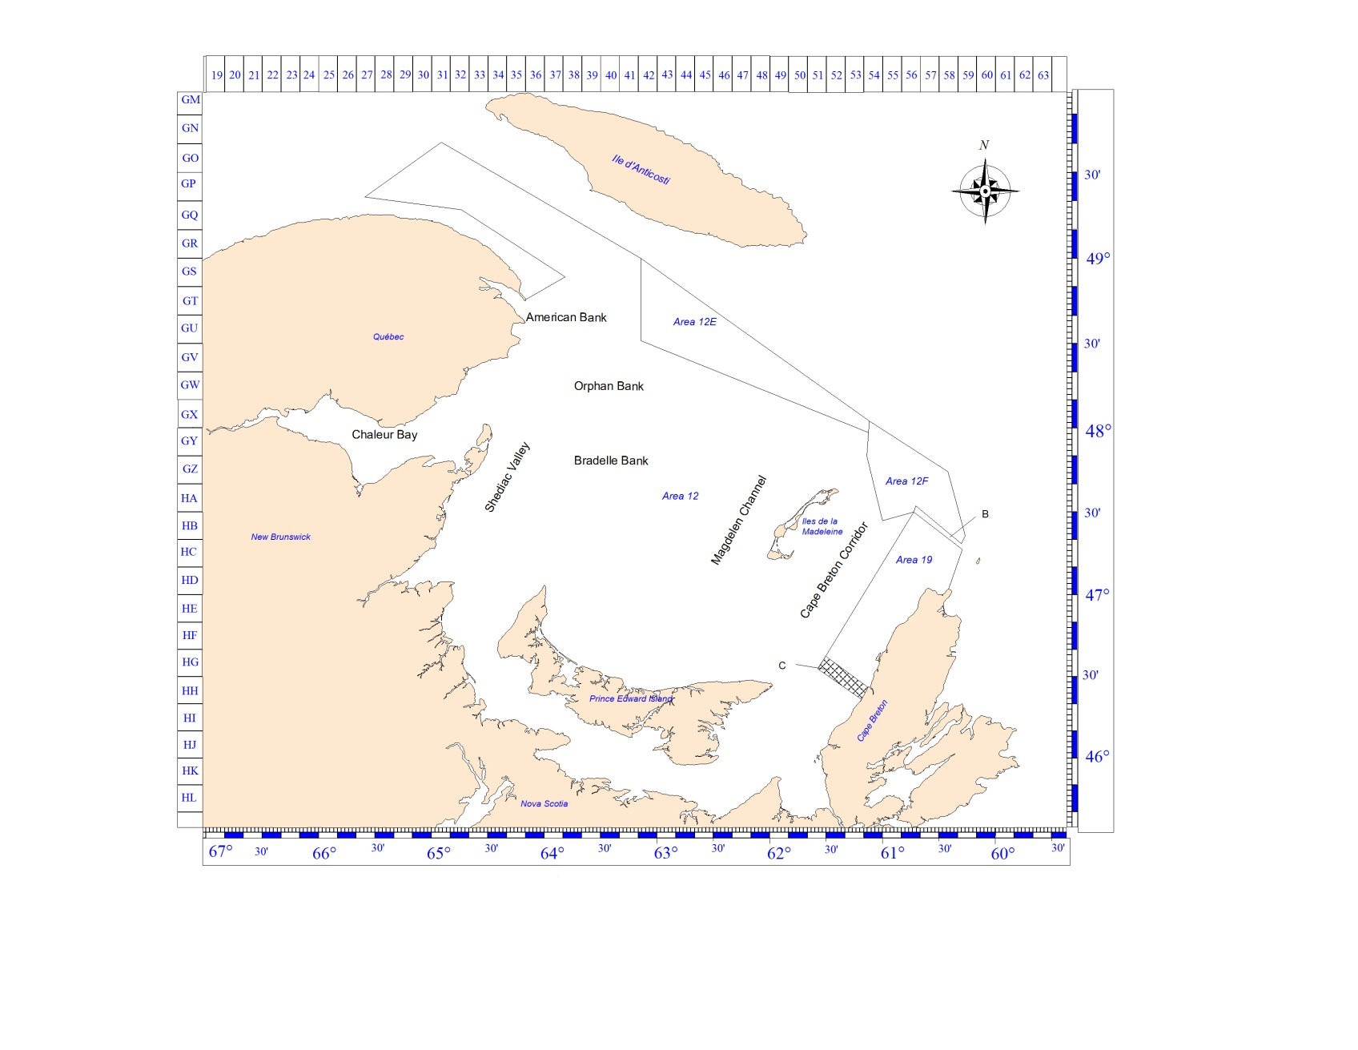*Figure 1. Map of the southern Gulf of St. Lawrence showing the snow crab (Chionoecetes opilio) fishing areas fishing grounds, and management buffer zones (labels B and C, shaded areas).*

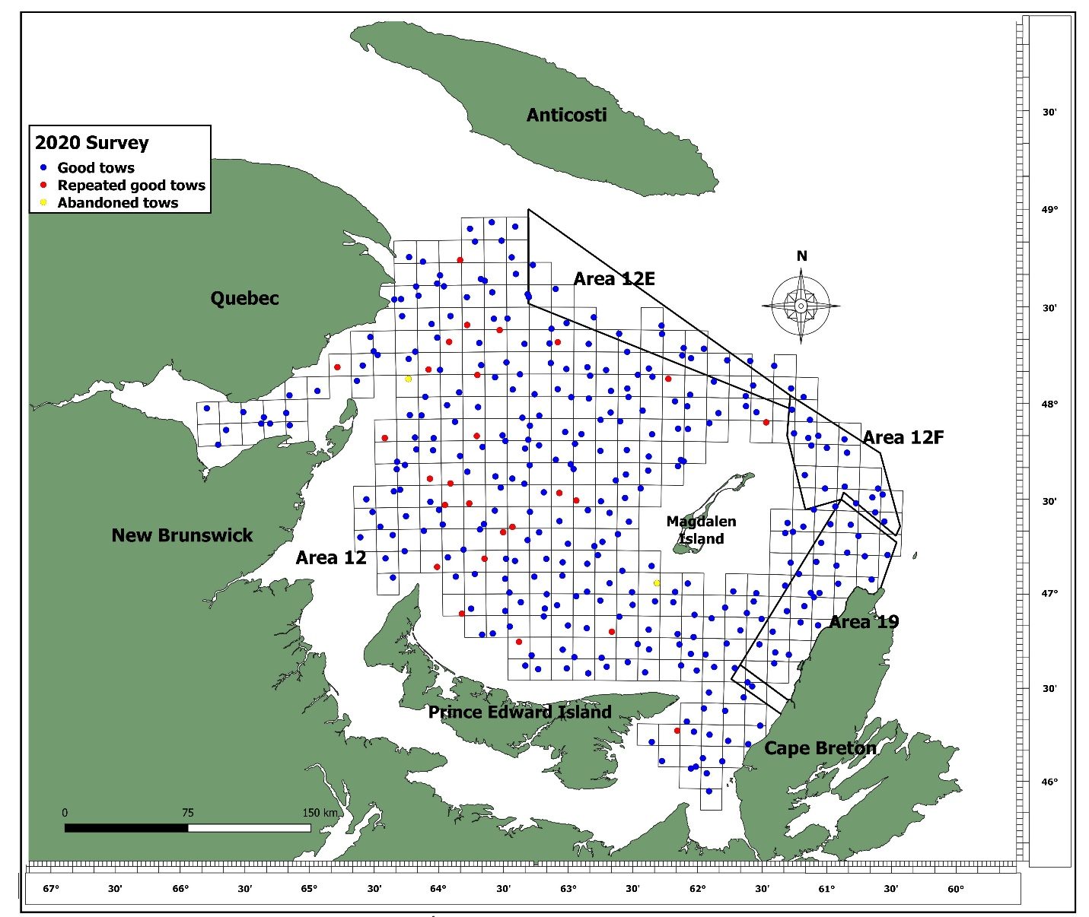

Figure 2. Locations of the 2020 snow crab (Chionoecetes opilio) trawl survey stations within the estimation polygon of 57,842.8 km2 in the southern Gulf of St. Lawrence. The blue points are successful tows, red points are successful repeat tows and yellow points are abandoned tows.

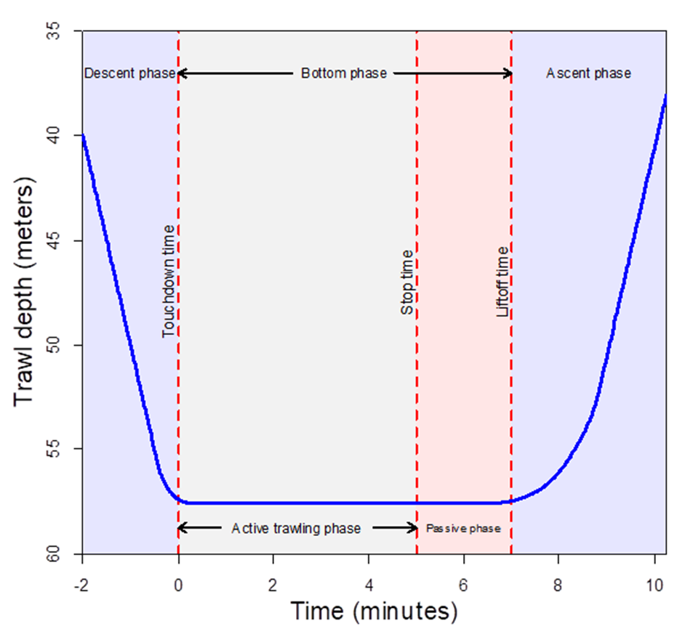

Figure 3. Trawl depth profile of a typical snow crab survey tow, showing the four phases of trawling.

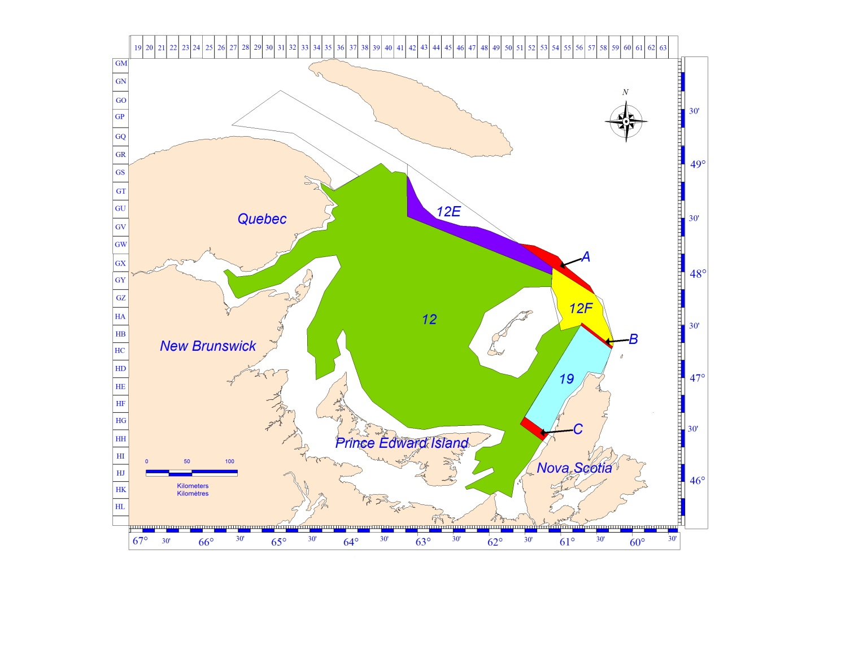

Figure 4. The estimation polygon of 57,842.8 km2 used for the 2020 snow crab (Chionoecetes opilio) stock assessment in the southern Gulf of St. Lawrence (all coloured areas) and corresponding estimation polygons for the four crab fishing areas (12, 12E, 12F and 19). The unassigned zone north of areas 12E and 12F (label A) and buffer zones (labels B and C) are also shown.

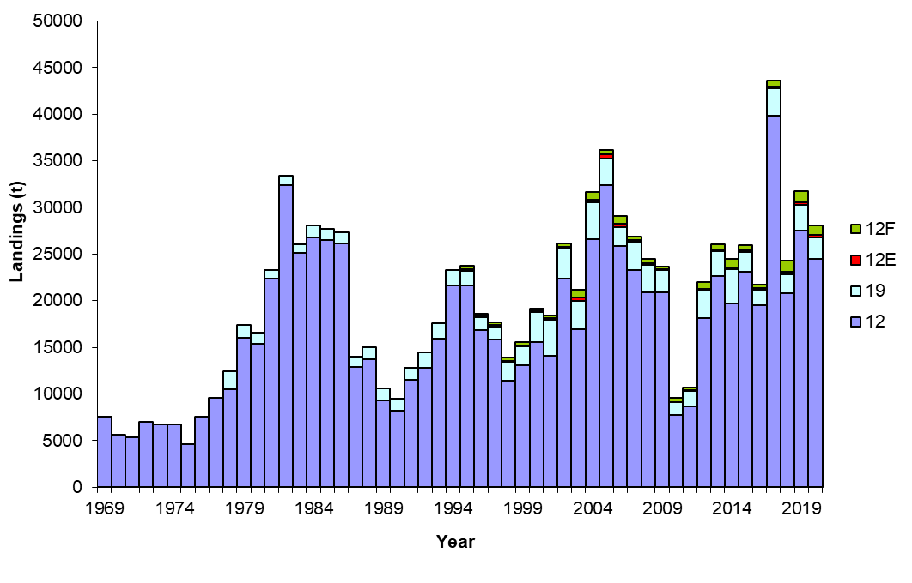

Figure 5. Landings (t) by fishing area and overall in the southern Gulf of Saint Lawrence snow crab fishery, 1969 to 2020.

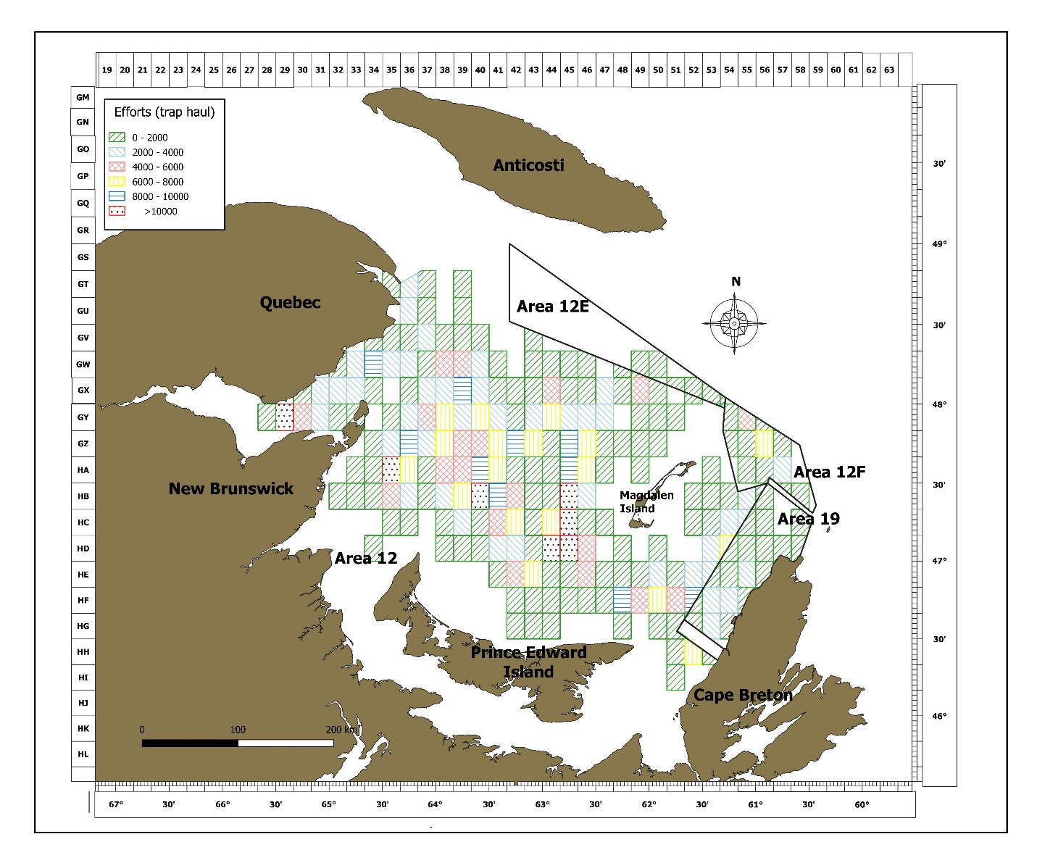

*Figure 6. Geographic distribution of fishing effort (trap hauls) by snow crab fishery management area during the 2020 fishing season.*

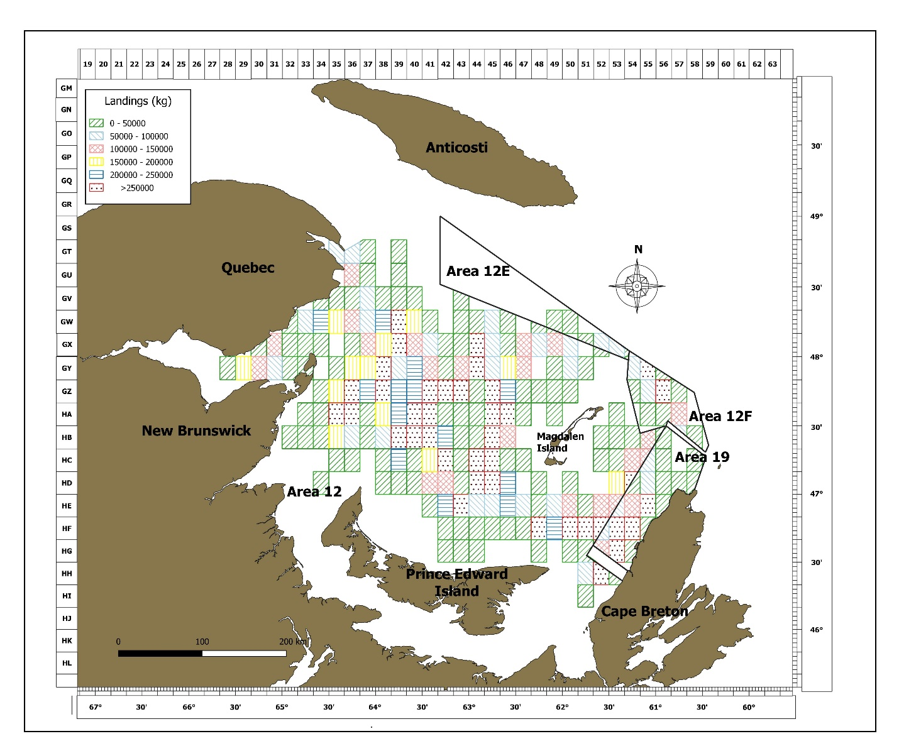

*Figure 7. Geographic distribution of landings (kg) in snow crab fishing management areas during the 2020 fishing season.*

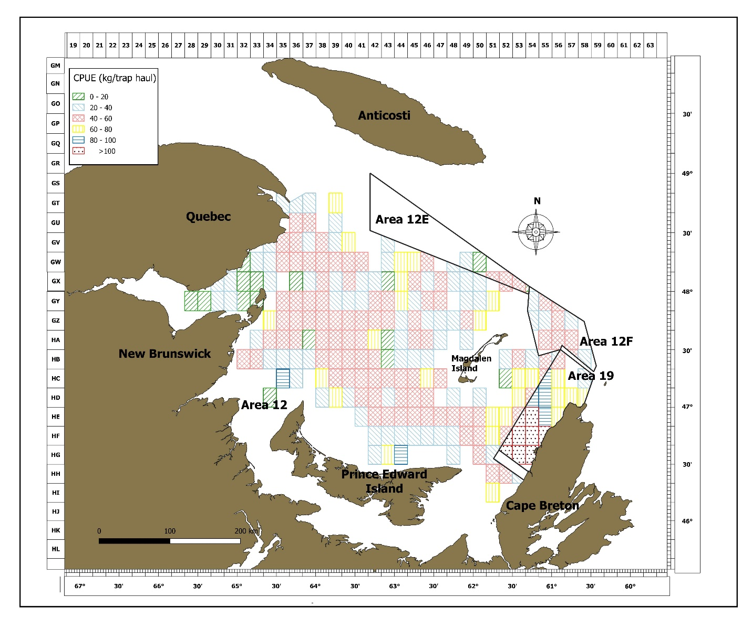

*Figure 8. Geographic distribution of mean catch-per-unit-of-effort (CPUE; kg / th), in the snow crab fishery management areas during the 2020 fishing season.*



Figure 9. Survey vessel tracks during the active trawling phase (grey lines) and during the passive phase (red lines). Tracks are shifted relative to the vessel position at the tilt touchdown time (center point).



Figure 10. Three-year moving average variogram models for commercial-sized adult male snow crab (Chionoecetes opilio) in the southern Gulf of St. Lawrence, 2013 to 2020. Indicated is the number of paired observations used per distance lag semi-variance calculation. The red dashed lines indicate the range value on the abscise axis and the nugget and sill values on the y axis. The green dashed line indicates the variance on the y axis.

**

Figure11. Density (kg per km²) contours of commercial-sized (≥ 95 mm of carapace width) adult male snow crab (Chionoecetes opilio) based on trawl survey data in the southern Gulf of St. Lawrence, 2010 to 2020.

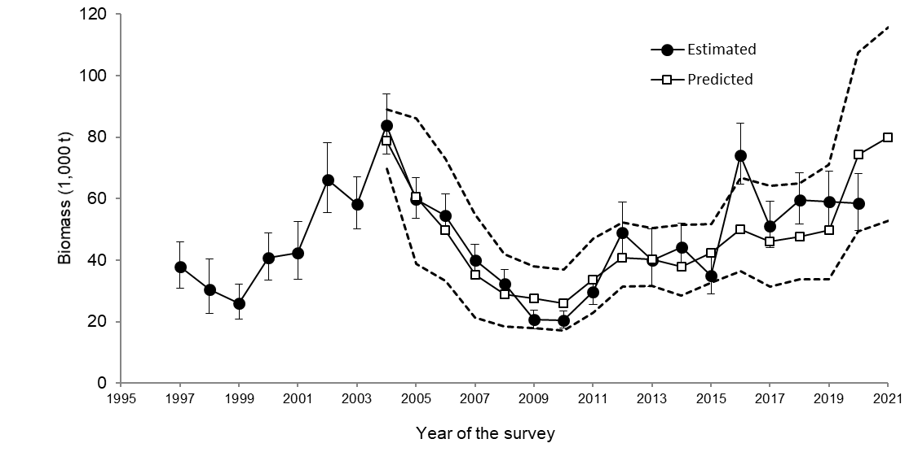

Figure 12. Comparison between the observed (mean with 95% confidence intervals) and forecasted (mean with 95% confidence intervals) recruitment (R-1) of male snow crab (Chionoecetes opilio) based on the Bayesian model on prerecruits (Surette and Wade 2006; Wade et al. 2014).

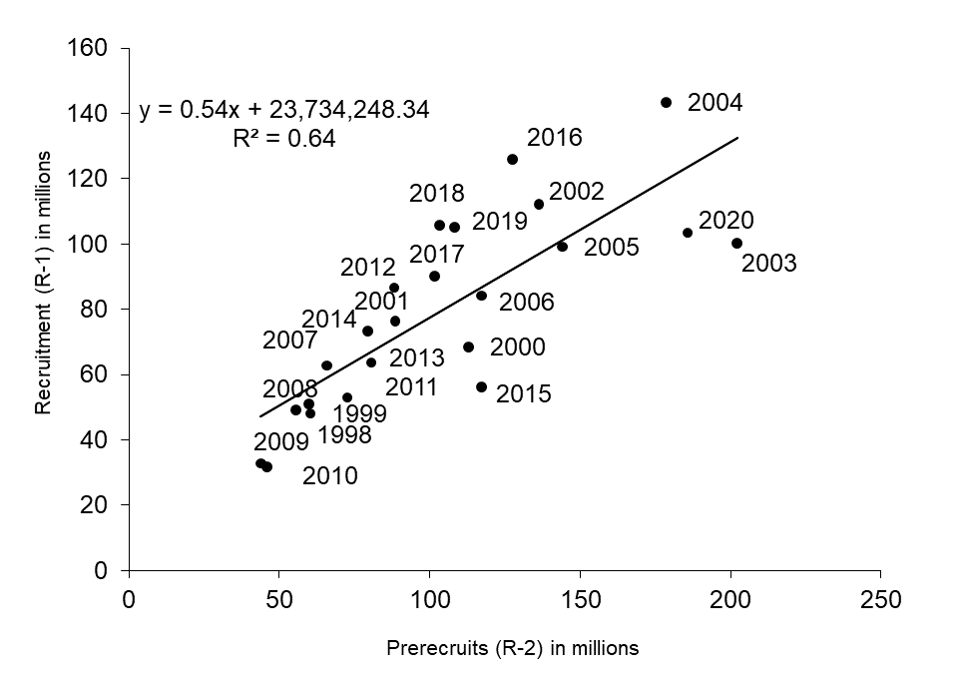

Figure 13. Relationship between the estimated abundance of prerecruits R-2 in year t - 1 and the estimated abundance of the recruitment to the fishery (R-1) in year t from the trawl survey data for the snow crab (Chionoecetes opilio) assessment in the southern Gulf of St. Lawrence.

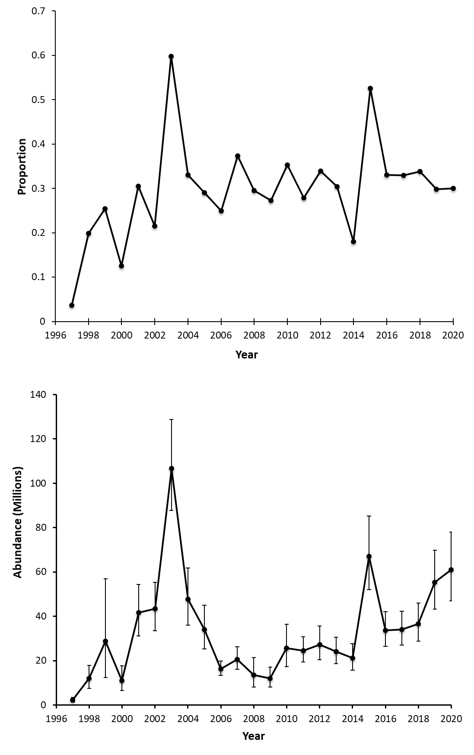

Figure 14. Abundance (in millions) (upper panel) and proportion (lower panel) of R-2 adolescent skip molters in the southern Gulf of St. Lawrence estimated from the trawl survey from 1997 to 2020.

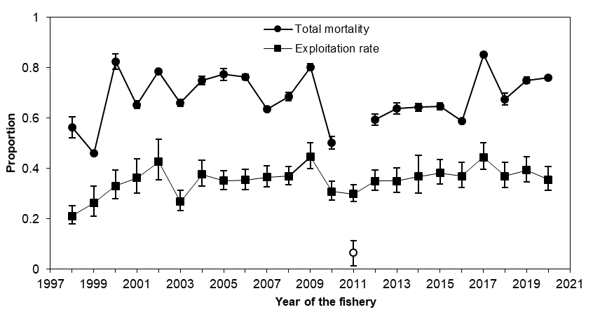

Figure 15. Estimated annual rates of exploitation and total loss of commercial-sized adult male snow crab (Chionoecetes opilio) in the southern Gulf of St. Lawrence, 1997 to 2020. The 2011 total mortality value is not reliable (Hébert et al. 2012).

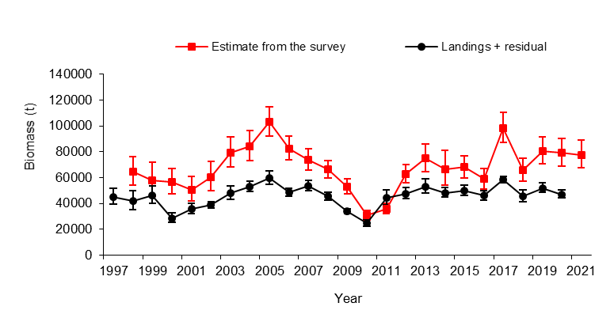

Figure 16. Comparison of the post-fishery calculated biomass (t; residual biomass plus the landings in year t+1) and the pre-fishery commercial-sized adult male snow crab (Chionoecetes opilio) biomass (t; recruitment plus residual biomass in year t) estimated from the trawl survey in the southern Gulf of St. Lawrence.

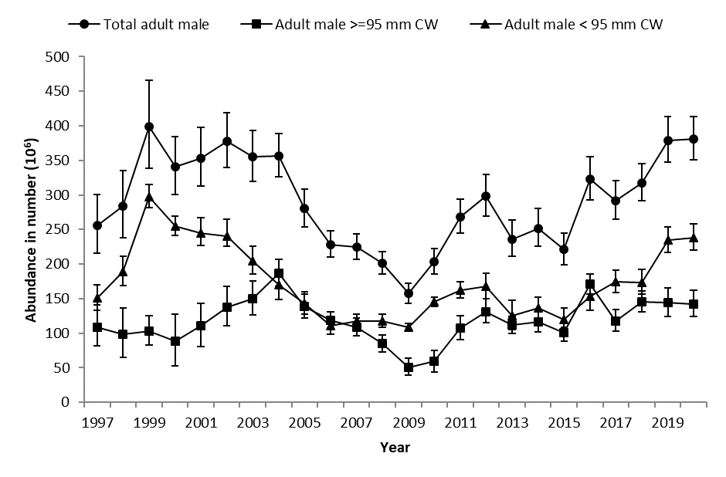

Figure 17. Estimated abundance (number in millions) of snow crab (Chionoecetes opilio) adult males in the southern Gulf of St. Lawrence, 1997 to 2020. CW = Carapace width.

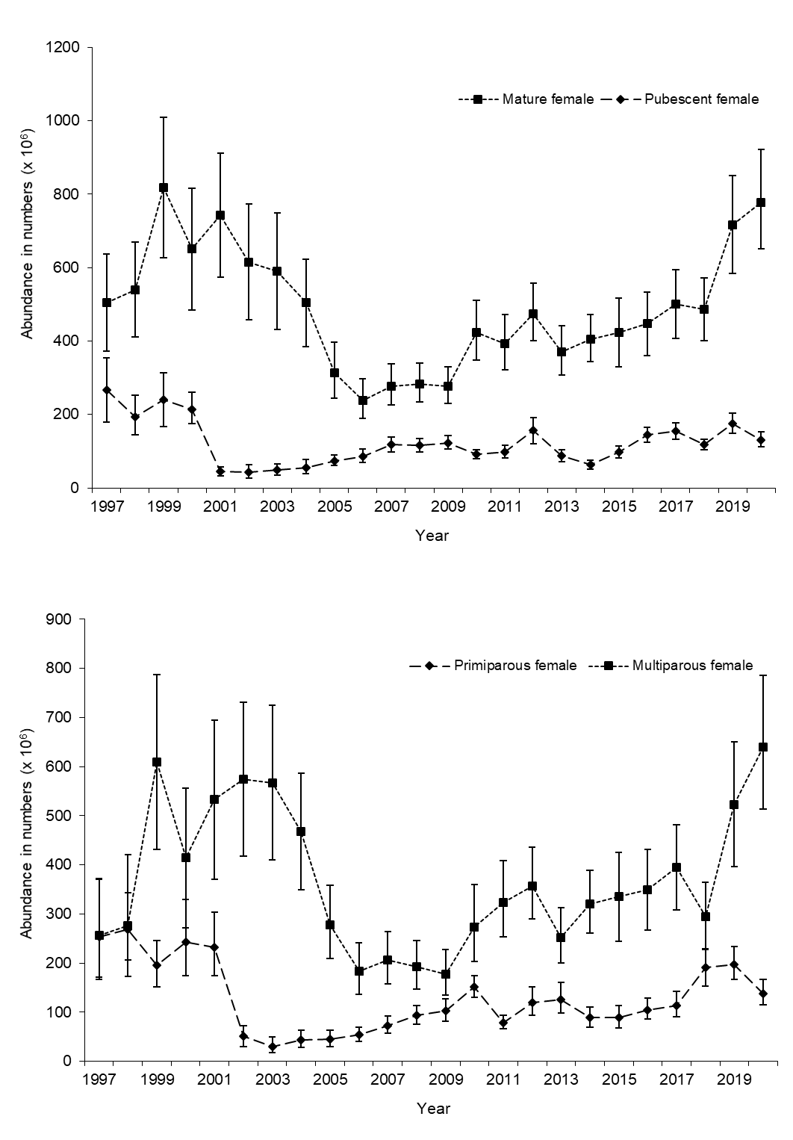

Figure 18. Abundance (number in millions) of mature and pubescent (above), and primiparous, and multiparous (i.e. mature; below) snow crab (Chionoecetes opilio) females in the southern Gulf of St. Lawrence, 1997 to 2020.

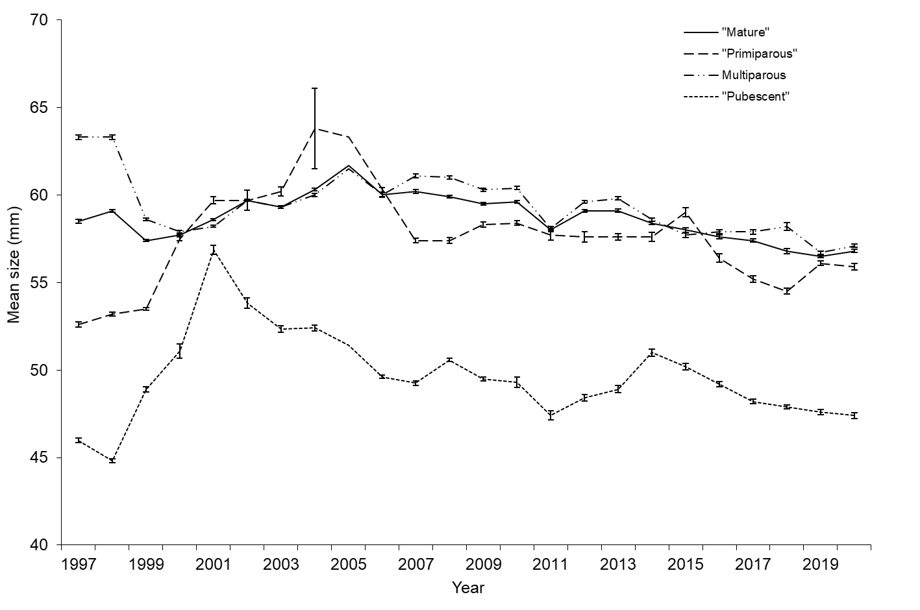

Figure 19. Mean size (carapace width in mm) with standard errors of pubescent, primiparous, multiparous and mature snow crab (Chionoecetes opilio) females based on samples from the trawl surveys, 1997 to 2020.

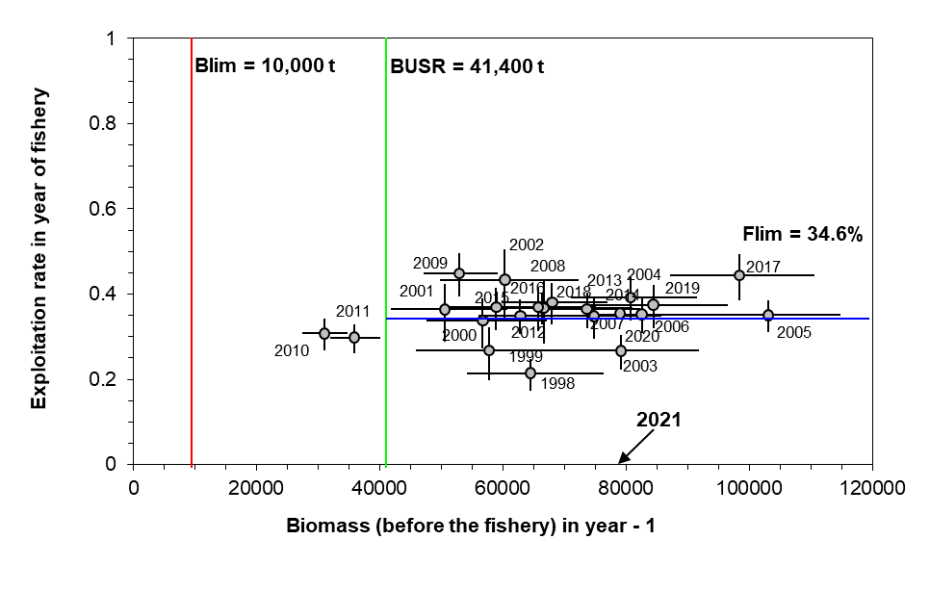Figure 20. Trajectory of stock abundance (biomass of commercial-sized adult male snow crab (Chionoecetes opilio) as estimated from the trawl survey in year t – 1 versus exploitation rate of this biomass in the fishery of year t. Year of the fishery is labelled on the figure. Blim = The limit reference point for biomass; Flim = Fishing removal rate limit reference point; BUSR = The upper stock reference point.



Figure 21. Snow crab (Chionoecetes opilio) recruitment (R) abundance (mean with 95% confidence intervals) by pre-recruit stages (Rj), where j =1,…,4 years until recruitment to the fishery based on the survey data estimates. Shaded areas are forecasted abundance from the Bayesian model (Wade et al. 2014).

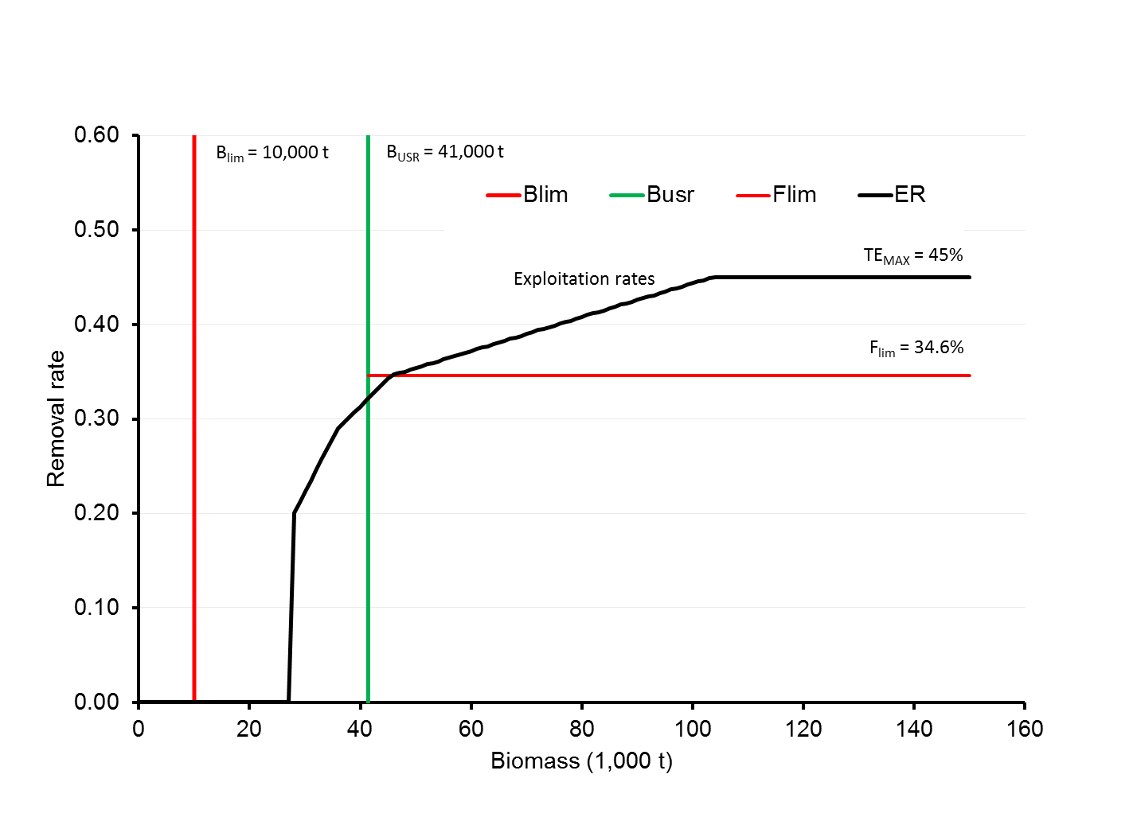

Figure 22. Harvest proportional decision rule (variant 4) compliant with the precautionary approach for the southern Gulf of St. Lawrence snow crab (Chionoecetes opilio) fishery (DFO 2014a). Blim = The limit reference point for biomass; Flim = Fishing removal rate limit reference point; BUSR = The upper stock reference point; ER = The exploitation rates based on the proportional harvest decision rule; TEmax = The maximum exploitation rate based on the proportional harvest decision rule.

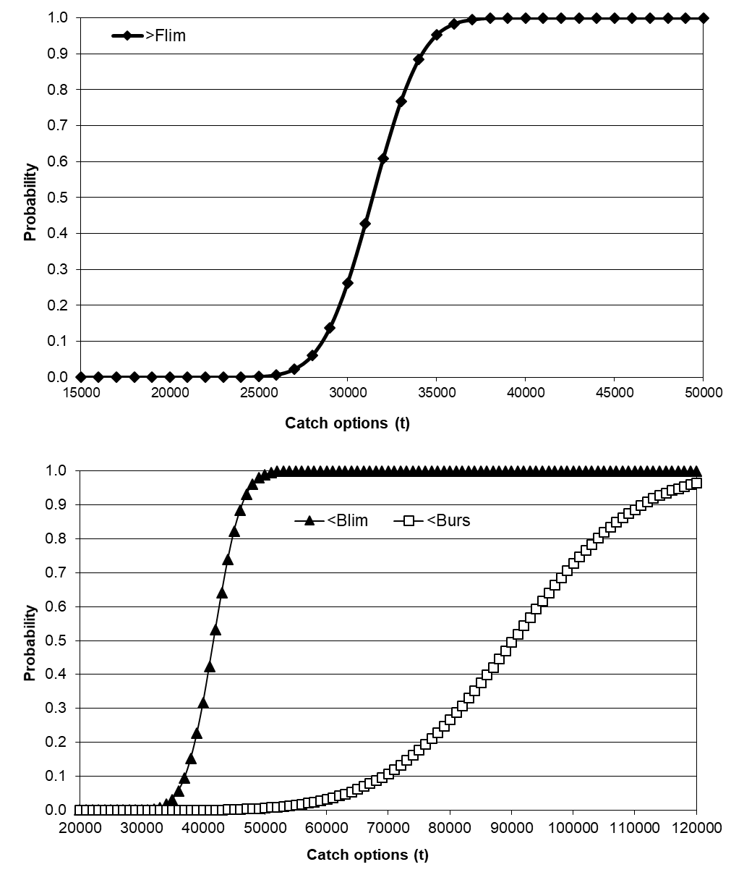

Figure 23. Risk analysis of catch options (t) for the 2020 fishery based on the expanded polygon for the southern Gulf of St. Lawrence snow crab, Chionoecetes opilio, showing probabilities of exceeding the fishing removal rate limit reference point (Flim), of the hard-shelled commercial-sized adult male residual biomass in 2021 falling below the limit reference point for biomass (Blim) and of the commercial-sized adult male biomass in 2021 will be below the upper reference point (BUSR) after the 2021 fishing season.

**

Figure 24. Size frequency distributions (by 1 mm carapace width interval) for male snow crabs (white bars are adult males and black bars are adolescent males) based on samples from the post-fishery trawl surveys in the southern Gulf of St. Lawrence, 2005 to 2020. These size frequency distributions represent the mean number of male snow crab (Chionoecetes opilio) per km2 based directly on samples in the trawl survey. The red dotted line represents the minimum legal size of 95 mm of carapace width,

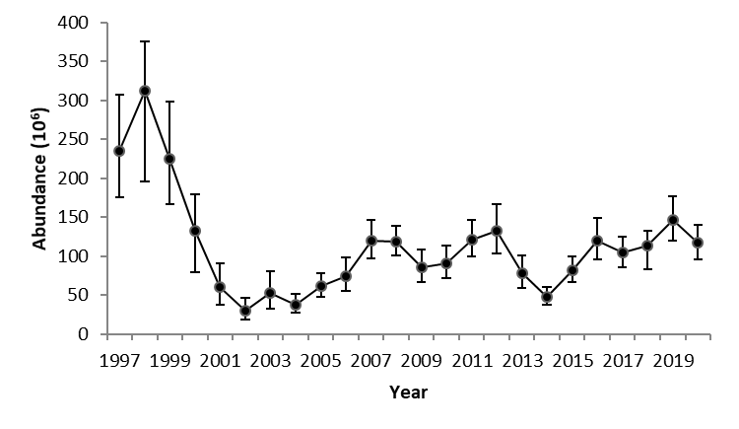

Figure 25. Abundance indices of small adolescent male snow crab (Chionoecetes opilio) with carapace width between 34 to 44 mm estimated from the trawl survey data in the southern Gulf of St. Lawrence, 1997 to 2020. These are crabs which reach legal size in approximately 6 years.



Figure 26. Density (number per km²) contours of adolescent male (R-4, R-3 and R-2) snow crab, (Chionoecetes opilio), ≥ 56 mm of carapace width, based on the trawl surveys conducted in the southern Gulf of St. Lawrence, 2010 to 2020.

**

Figure 27. Size frequency distributions (carapace width by 1 mm interval) for female (white bars are mature females and black bars are pubescent and immature females) snow crab (Chionoecetes opilio) based on samples from the post-fishery trawl surveys in the southern Gulf of St. Lawrence, 2005 to 2020. These size frequency distributions represent the mean number of female crab per km2 directly based on samples in the trawl survey.

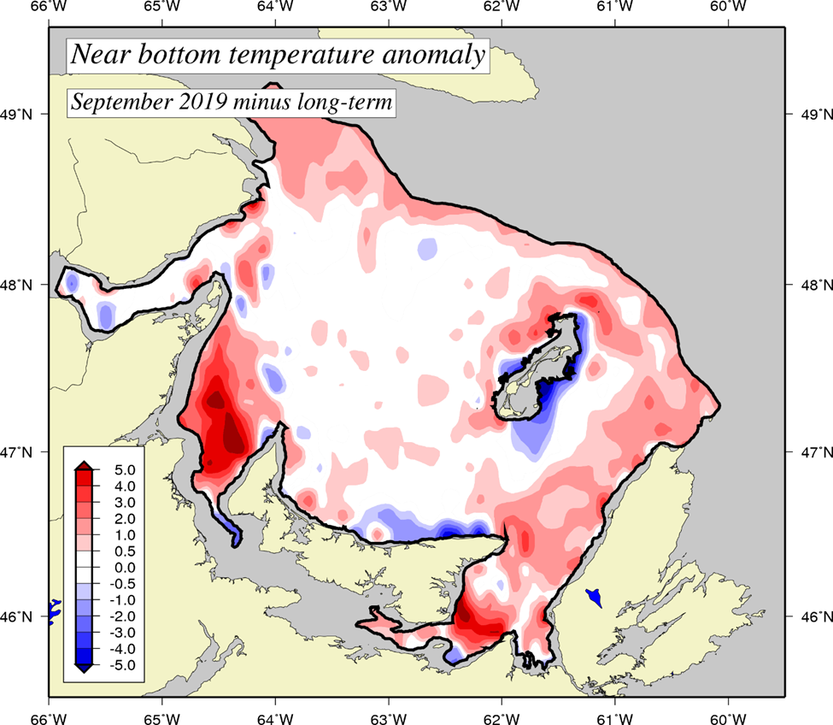

*Figure 28*. *Near-bottom temperature departure (°C) from the long-term (1981-2010) mean in the southern Gulf of St. Lawrence during the 2020 September multi-species survey. Blue areas represent colder-than-normal temperatures while red regions represent warmer-than-normal conditions.*

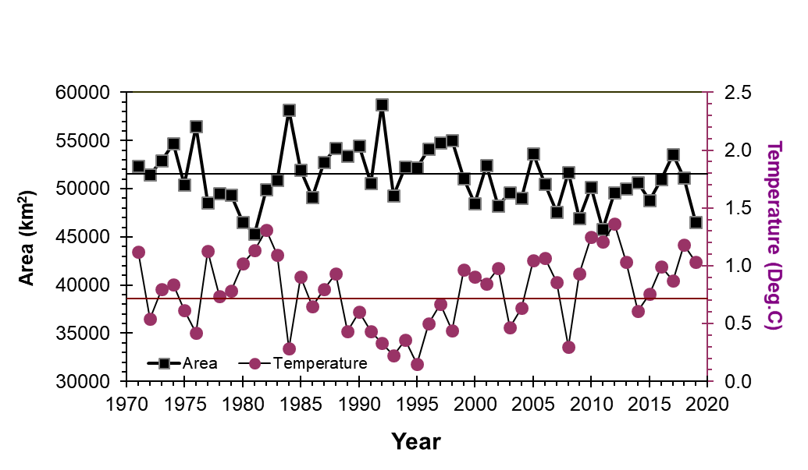

Figure 29. Snow crab temperature habitat area index (km2) that encompasses water temperatures of -1 to 3°C (upper panel) and the mean temperature (°C) within the temperature area index (lower panel) in the southern Gulf of St. Lawrence, 1971 to 2020.